## 1 Line graph Electricity Production in France from 1980 to 2012

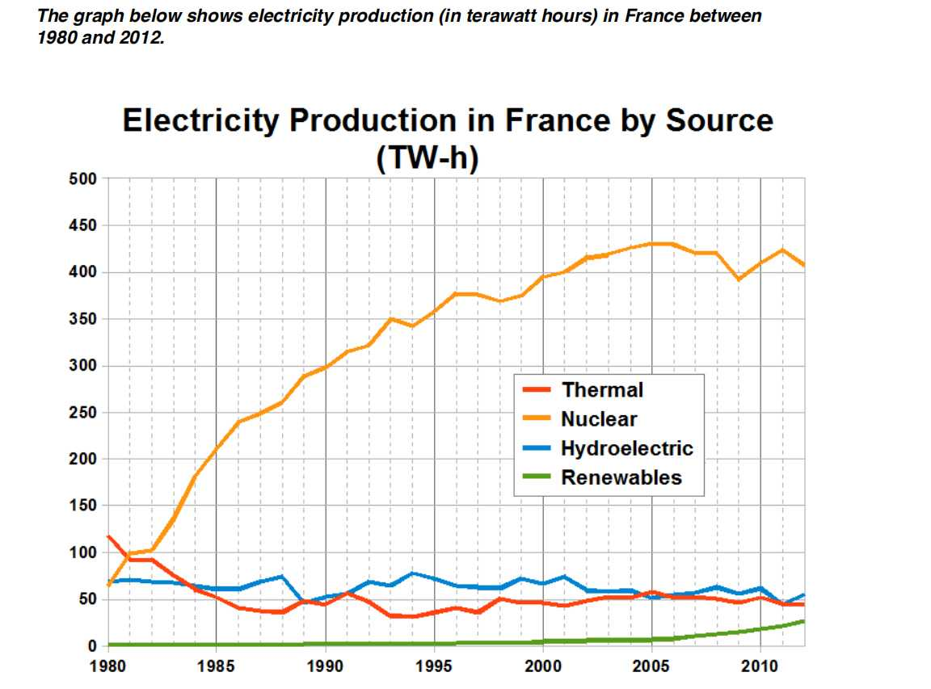

**Title:**

Electricity Production in France from 1980 to 2012

**Introduction:**

The line graph illustrates the quantity of electricity generated in France, measured in terawatt hours (TW-h), across various energy sources from 1980 to 2012.

**Overview:**

In general, the data shows a noticeable increase in electricity production in France over the three-decade period. Nuclear energy was the dominant source throughout, with thermal, hydroelectric, and renewable sources contributing to a lesser extent.

**Body:**

Nuclear energy consistently produced the highest volume of electricity, starting at approximately 200 TW-h in 1980 and peaking at around 400 TW-h in the year 2000 before slightly decreasing to just under 350 TW-h by 2012.

Thermal energy production showed a fluctuating pattern, with levels around 50 TW-h in 1980, increasing to a peak of about 150 TW-h in the mid-1990s, and then declining to around 100 TW-h by 2012.

Hydroelectric power exhibited a steady growth from just above 50 TW-h in 1980 to nearly 150 TW-h in 2012. This represents a significant increase, although from a lower base compared to nuclear and thermal energy.

Renewable energy sources, while starting at the lowest level of production at less than 50 TW-h in 1980, experienced the most substantial growth rate among all sources, reaching nearly 150 TW-h by 2012.

**Conclusion:**

To sum up, nuclear energy remained the primary source of electricity in France over the period in question, with thermal energy also playing a significant role. Both hydroelectric and renewable energy sources experienced growth, with renewables showing the most considerable increase, indicating a possible shift towards more sustainable energy production methods.

## 2 map town now and planned

**Title:**

Revolutionizing Islip: A Vision for Town Centre Development

**Introduction:**

The maps present a striking comparison between the current state of Islip town centre and an ambitious plan for its future development. This essay will outline the proposed changes and discuss their potential impact on the town.

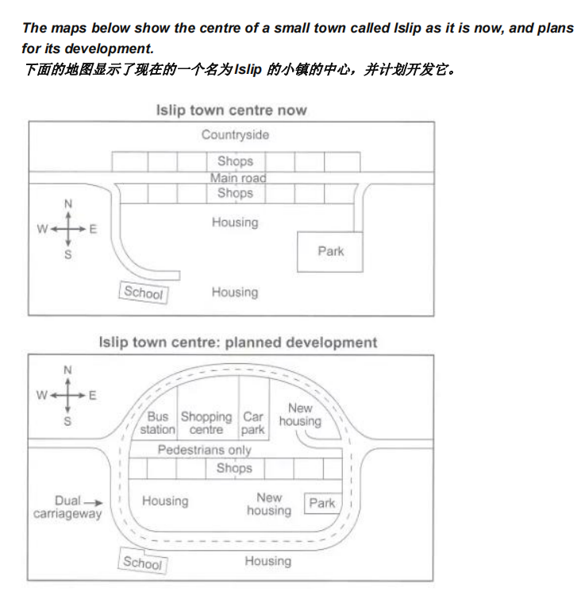**Body:**

The existing town centre of Islip, as depicted, is a quaint setup with a mix of housing, shops, a school, and a park, all centered around the main road that leads into the countryside. However, the proposed development plan envisions a more integrated and modern community.

Key elements of the plan include the introduction of a new shopping centre, designed to invigorate the local economy and offer enhanced amenities to residents. The expansion of housing is also a significant aspect, suggesting a response to population growth or an effort to draw new inhabitants to the area.

Transportation is set to be revolutionized with the addition of a bus station and a dual carriageway, promising improved connectivity and reduced congestion. Moreover, the creation of a pedestrian-only zone is a thoughtful gesture towards enhancing safety and the overall shopping experience.

The green space is also reconsidered, with plans to expand the park and potentially reposition the school, which could lead to a more harmonious integration of educational facilities within the community.

The diagrams illustrate some proposed changes to the central area of the town of Islip.

It is clear that the principal change to the town will be the construction of a ring road

around the centre. Various other developments with regard to shops and housing will

accompany the building of this road.

Looking at the map of Islip as it is now, we can see that a main road runs through its

centre from east to west. The second map shows the planned pedestrianisation of this

road. Traffic will be diverted on to a dual carriageway that will form a ring around the town

centre.

Currently there is a row of shops along either side of the main road. However, it appears

that the shops along the north side of the new pedestrian street will be demolished to

make way for a bus station, shopping centre, car park and new housing area. The shops

along the south side of the street will remain, but it seems that the town’s park will be

reduced in size so that more new houses can be built within the ring road.

## 3 reasons for travel

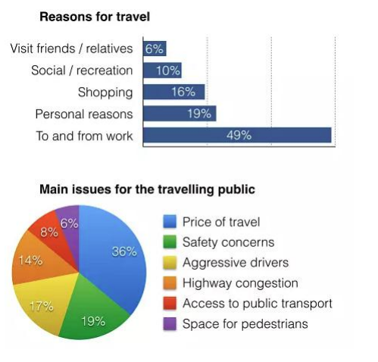

The bar chart and pie chart give information about why US residents travelled and what travel problems they experienced in the year 2009.

It is clear that the principal reason why Americans travelled in 2009 was to commute to and from work. In the same year, the primary concern of Americans, with regard to the trips they made, was the cost of travelling.

Looking more closely at the bar chart, we can see that 49% of the trips made by Americans in 2009 were for the purpose of commuting. By contrast, only 6% of trips were visits to friends or relatives, and one in ten trips were for social or recreation reasons. Shopping was cited as the reason for 16% of all travel, while unspecific ‘personal reasons’ accounted for the remaining 19%.

According to the pie chart, price was the key consideration for 36% of American travellers. Almost one in five people cited safety as their foremost travel concern, while aggressive driving and highway congestion were the main issues for 17% and 14% of the travelling public. Finally, a total of 14% of those surveyed thought that access to public transport or space for pedestrians were the most important travel issues.

The charts below show reasons for travel and the main issues for the travelling public in the US in 2009.

In the first chart, we see a bar graph that illustrates the percentage of travel reasons among the population. The most common reason for travel is to and from work, accounting for 49% of all trips. This is followed by personal reasons at 19%, shopping at 16%, social/recreation at 10%, and visiting friends/relatives at 6%. These figures suggest that work-related travel is the primary mode of movement, with personal, shopping, social, and visiting activities also playing significant roles.

The second chart is a pie chart that outlines the main concerns of the traveling public. Safety concerns top the list at 36%, indicating a significant worry among travelers. Aggressive drivers are a concern for 19%, which may be related to safety but reflects specific driver behavior as an issue. Highway congestion follows closely at 17%, reflecting frustrations with traffic conditions. Access to public transport is a concern for 14%, suggesting limitations or inefficiencies in public transit systems. Lastly, space for pedestrians accounts for 6%, highlighting the importance of walkability and pedestrian infrastructure.

## 4 school children problem areas

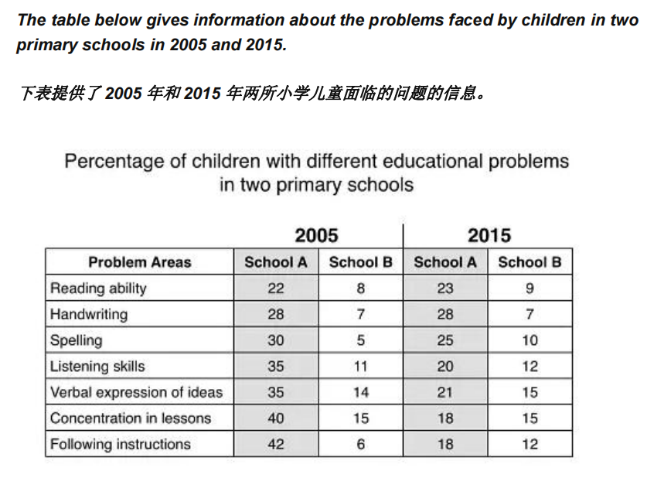

The table compares educational challenges in two primary schools, School A and School B, in 2005 and 2015.

In 2005, School A had higher percentages of children with reading ability (22%) and handwriting (28%) issues compared to School B (8% and 7%, respectively). By 2015, these gaps narrowed slightly.

Spelling was a concern for 30% of children in School A in 2005, decreasing to 25% by 2015, while School B saw an increase from 5% to 10%.

Listening skills were a significant issue in both schools in 2005, with a notable decrease in School A to 20% by 2015, while School B increased slightly to 12%.

Verbal expression of ideas was a challenge for 35% of children in School A in 2005, decreasing to 21% by 2015, and School B increased from 14% to 15%.

Concentration in lessons was a major concern in 2005, with a significant decrease in School A to 18% by 2015, and a slight increase in School B to 15%.

Following instructions was the most challenging area in 2005, with a substantial decrease in School A to 18% by 2015, and a slight increase in School B to 12%.

Overall, there have been some improvements over the decade, particularly in School A, but certain areas remain significant concerns.

## 5 British visitors

***The chart below shows the results of a survey of people who visited four types of***

***tourist attraction in Britain in the year 1999.***

***下图显示了 1999 年访问英国四种旅游景点的人的调查结果。***



The pie chart presents data on the distribution of visitors to various tourist attractions in Britain during 1999. The largest segment, representing 37% of visitors, is attributed to museums and galleries, indicating their popularity as cultural destinations. Theme parks follow closely with a 35% share, suggesting a strong interest in entertainment-based attractions. Historic houses and monuments account for 16% of visitors, reflecting a significant but lesser interest in historical sites. Wildlife parks and zoos are the least visited, making up only 9% of the total.

The chart also includes specific examples of each attraction type, such as Blackpool Pleasure Beach for theme parks and Chessington World of Adventures for museums and galleries, providing context to the categories. These details offer insights into the preferences of tourists in Britain during that period, with a clear preference for cultural and entertainment-based experiences over purely recreational or historical visits. The chart effectively communicates these trends through its clear segmentation and labeling, allowing for an immediate understanding of the data's implications on tourism in Britain.

## 6 'waste graph' answer



The line graph compares three companies in terms of their waste output between the

years 2000 and 2015.

It is clear that there were significant changes in the amounts of waste produced by all

three companies shown on the graph. While companies A and B saw waste output fall

over the 15-year period, the amount of waste produced by company C increased

considerably.

In 2000, company A produced 12 tonnes of waste, while companies B and C produced

around 8 tonnes and 4 tonnes of waste material respectively. Over the following 5 years,

the waste output of companies B and C rose by around 2 tonnes, but the figure for

company A fell by approximately 1 tonne.

From 2005 to 2015, company A cut waste production by roughly 3 tonnes, and company B

reduced its waste by around 7 tonnes. By contrast, company C saw an increase in waste

production of approximately 4 tonnes over the same 10-year period. By 2015, company

C’s waste output had risen to 10 tonnes, while the respective amounts of waste from

companies A and B had dropped to 8 tonnes and only 3 tonnes.

## 7 separate line graphs

The first chart below gives information about the money spent by British parents on their

children’s sports between 2008 and 2014. The second chart shows the number of children

who participated in three sports in Britain over the same time period.



The first chart illustrates the average monthly expenditure by British parents on their children's sports over a span of seven years, from 2008 to 2014. The spending is measured in pounds. In 2008, the spending was approximately £20 million per month. There is a gradual increase each year, reaching nearly £35 million by 2014. This suggests a steady growth in investment in children's sports over this period.

The second chart shows the participation of children in three specific sports: football, athletics, and swimming. The data is presented as the number of children (in millions) participating in each sport over the same time frame from 2008 to 2014.

In 2008, around 7.5 million children participated in football, which is the highest among the three sports. Athletics had roughly 5 million participants, and swimming had approximately 2.5 million participants.

By 2014, there is a noticeable increase in the number of children participating in all three sports. Football participation has increased to about 10 million children. Athletics participation has risen to around 7.5 million, and swimming participation has more than doubled to approximately 5 million children.

## 8 pie charts report

**The charts below show the results of a questionnaire that asked visitors to the**

**Parkway Hotel how they rated the hotel's customer service. The same**

**questionnaire was given to 100 guests in the years 2005 and 2010.**

The charts are pie charts that represent the results of a customer service satisfaction survey conducted at the Parkway Hotel in two different years: 2005 and 2010. Each chart is divided into four segments, each corresponding to a different rating given by the guests: "Excellent," "Good," "Satisfactory," and "Poor."

In the 2005 chart, the largest segment is labeled "Excellent" and accounts for 45% of the responses. The next largest segment is "Good," which makes up 21%. The "Satisfactory" category represents 17%, and the smallest segment is "Poor," which accounts for 15%.

In the 2010 chart, the distribution of ratings is slightly different. The "Excellent" category remains the largest, but with a smaller percentage at 39%. The "Good" category increases to 28%. The "Satisfactory" category decreases to 12%, and the "Poor" category increases to 21%.

Comparing the two charts, there is a noticeable decrease in the percentage of guests rating the hotel's customer service as "Excellent" from 45% in 2005 to 39% in 2010. Conversely, there is an increase in the percentage of guests rating the service as "Poor," from 15% in 2005 to 21% in 2010.

Overall, the data suggests a slight decline in customer satisfaction with the hotel's customer service between 2005 and 2010.

## 9 pie charts comparing water usage in San Diego

**The pie charts below compare water usage in San Diego, California and the rest of**

**the world.**



The pie charts compare water usage across three sectors—Residential, Industry, and Agriculture—in San Diego County, California, and worldwide.

In San Diego County, the residential sector uses the most water, accounting for 60% of total usage. The industry sector uses 23%, and agriculture uses 17%.

For the state of California, the distribution is slightly different. The residential sector still uses the most water at 39%. However, the industry sector uses less at 28%, while agriculture uses more at 33%.

When looking at worldwide usage, the proportions change significantly. Agriculture uses the most water globally, accounting for 69%. The residential sector uses 23%, and the industry sector uses only 8%.

These charts highlight significant differences in water usage patterns between a local county, a larger state, and the world as a whole. San Diego County has a higher percentage of water usage for residential purposes compared to both California and worldwide figures. In contrast, agriculture's share of water usage is much higher worldwide than in San Diego County or California, indicating that agriculture is a major consumer of water globally.

## 10 Bar chart time of telephone calls

The chart below shows the total number of minutes (in billions) of telephone calls in the

UK, divided into three categories, from 1995-2002.



The chart is a bar graph that displays the total number of minutes (in billions) of telephone calls in the UK from 1995 to 2002. The calls are categorized into three types: Local - fixed line, National and international - fixed line, and Mobiles (all calls).

For local fixed-line calls, there is a general upward trend over the years. Starting at approximately 60 billion minutes in 1995, it peaks around 80 billion minutes in 1999 before slightly decreasing to about 70 billion minutes by 2002.

National and international fixed-line calls also show an increase over time, starting at roughly 40 billion minutes in 1995 and reaching nearly 60 billion minutes by 2002.

Mobile phone usage, represented as "Mobiles (all calls)," shows a dramatic increase from just under 10 billion minutes in 1995 to over 60 billion minutes by 2002.

Overall, the graph indicates a significant growth in mobile phone usage over the seven-year period, while local fixed-line was nearly back to the same number by 2002，and national/international fixed-line calls saw increases but at a slower rate compared to mobiles.

## 11 Living alone in England by age and gender, 2011

The bar chart below shows the proportions of English men and women of different ages

who were living alone in 2011. The pie chart compares the numbers of bedrooms in these

one-person households.

Living alone in England by age and gender, 2011



The two charts give information about single-occupant households in England in the year 2011. The bar chart compares figures for occupants' age and gender, and the pie chart shows data about the number of bedrooms in these homes.

The bar chart illustrates the proportions of men and women in England who were living alone in 2011, categorized by age groups. The chart shows that across all age groups, a higher percentage of women than men lived alone. The percentages increase with age, reaching the highest proportion among those aged 85 and over.

Number of bedrooms in one-person households (England, 2011)

The pie chart provides information on the distribution of bedrooms in one-person households in England during the same year. It shows that the majority of these households had either one or two bedrooms, with 35.4% having one bedroom and 28.0% having two bedrooms. A smaller portion had three bedrooms (11.4%), while even fewer had four or more bedrooms (5.3%). This suggests that most individuals living alone in England in 2011 resided in relatively small accommodation.

## 12 coffee and bananas' table

The tables below give information about sales of Fairtrade*-labelled coffee and bananas

in 1999 and 2004 in five European countries.



*Fairtrade: a category of products for which farmers from developing countries have been

paid an officially agreed fair price.

The table presents sales data for Fairtrade-labeled coffee and bananas in the years 1999 and 2004, comparing figures across four European countries: the UK, Switzerland, Denmark, Belgium, and Sweden. For coffee, the UK shows a significant increase from 1.5 million euros in 1999 to 20 million euros in 2004. Switzerland also saw an increase from 3 million euros to 6 million euros. Denmark's sales remained relatively stable at about 1.8 million euros, while Belgium and Sweden experienced slight decreases.

For bananas, the UK again leads with a substantial increase from 15 million euros to 47 million euros. Switzerland's sales more than doubled from 1 million euros to 5.5 million euros. Denmark's sales increased slightly from 0.6 million euros to 4 million euros. Belgium and Sweden both saw modest increases, with Belgium going from 1.8 million euros to 1 million euros and Sweden from 2 million euros to 0.9 million euros.

This data suggests a growing market for Fairtrade products in these countries, particularly in the UK, which experienced significant growth in both coffee and banana sales over the five-year period. The overall trend indicates a positive development for Fairtrade producers, as there is a clear increase in consumer demand for their products within these European markets.

## 13 'school buildings' diagram

The diagrams below show the site of a school in 2004 and the plan for changes to the

school site in 2024.

The diagrams depict the layout of a school site in two different years, 2004 and a projected plan for 2024. In 2004, the school had 600 students and featured a central building labeled as "SCHOOL BUILDING," with various other facilities such as a "CUT-THROUGH," "CAR PARK," "SPORTS FIELD," and "PARKING." Surrounding the central building are trees, pathways, and smaller structures that could be additional classrooms or facilities.

In the 2024 plan, the student population is projected to increase to 1,000 students. The layout shows an expansion with two new buildings labeled "SCHOOL BUILDING 2" and "SCHOOL BUILDING 3," suggesting an increase in classroom space or facilities. There is also a new "CUT-THROUGH" path and an expanded "CAR PARK," indicating provisions for increased traffic and student numbers. The sports field remains in a similar location, but there are more trees depicted, possibly indicating an expansion of green spaces or a beautification effort.

The changes suggest a response to growth in student population, with an emphasis on expanding educational facilities and improving infrastructure to accommodate the increase. The addition of more trees might also indicate a commitment to maintaining green spaces despite development.

## 14 'age distribution'

The charts below compare the age structure of the populations of France and India in

1984.



The two charts compare the populations of France and India in terms of age distribution

by gender in the year 1984.

It is clear that the population of India was younger than that of France in 1984, with a

noticeably larger proportion of people aged under 20. France, on the other hand, had a

significantly larger percentage of elderly inhabitants.

In India, close to 14% of people were aged 5 or under, and each five-year age bracket above this contained an increasingly smaller proportion of the population. France’s

population, by contrast, was more evenly distributed across the age ranges, with similar figures (around 7% to 8% of all people) for each five-year cohort between the ages of 0 and 40. Somewhere between 10% and 15% of all French people were aged 70 or older, but the equivalent figure for India was only 2%.

Looking more closely at gender, there was a noticeably higher proportion of French

women than men in every cohort from age 50 upwards. For example, almost 3% of

French 70- to 75-year-olds were women, while just under 2% were men. No significant

gender differences can be seen on the Indian population chart.

## 15 dangerous waster dealing pie chart

The pie charts below show how dangerous waste products are dealt with in three

countries.



The charts compare Korea, Sweden and the UK in terms of the methods used in each

country to dispose of harmful waste.

It is clear that in both the UK and Sweden, the majority of dangerous waste products are

buried underground. By contrast, most hazardous materials in the Republic of Korea are

recycled.

Looking at the information in more detail, we can see that 82% of the UK’s dangerous

waste is put into landfill sites. This disposal technique is used for 55% of the harmful

waste in Sweden and only 22% of similar waste in Korea. The latter country recycles 69%

of hazardous materials, which is far more than the other two nations.

While 25% of Sweden's dangerous waste is recycled, the UK does not recycle at all.

Instead, it dumps waste at sea or treats it chemically. These two methods are not

employed in Korea or Sweden, which favour incineration for 9% and 20% of dangerous

waste respectively.

## 16 'flood diagram'

The diagrams below show how houses can be protected in areas which are prone to

flooding.



The diagrams illustrate two scenarios for protecting houses in flood-prone areas. The first scenario, "Where there is a stopbank," shows a house situated behind a stopbank which serves as a barrier against floodwaters. The stopbank is designed to contain water at the 100-year flood level, preventing it from reaching the house. A berm and a freeboard above the stopbank provide additional protection. The house has an internal ponding area designed to handle water that may enter through the roof during heavy rainfalls.

In contrast, the second scenario, "Where there is no stopbank," depicts a house without such protective barriers. Here, the house is built with a raised floor level (300 mm above ground level) to protect against potential flooding. This design feature elevates the living space above the anticipated flood level, ensuring that the interior remains dry even when the surrounding ground is flooded up to the 100-year flood level.

Both scenarios demonstrate architectural adaptations to mitigate the risks associated with flooding. The use of stopbanks and raised building designs are practical solutions to protect homes and their occupants from the damaging effects of floods. These measures can significantly reduce the risk of property damage and ensure the safety of residents in flood-prone regions.

The diagrams compare two different methods of defence for homes which are at risk of

being flooded.

The key difference between the diagrams is that they show flood protection with and

without a stopbank. In either case, the at-risk home is raised on stilts above ground level.

The first diagram shows how a stopbank acts as a flood barrier to stop river water from

flooding homes. The stopbank is a small mound of land next to the river that is higher than

the 100-year flood level, and prevents the river from bursting its banks. Nearby houses

can be built on stilts to prevent flooding from rainwater, and a floodgate beneath the

stopbank can be opened to allow this ‘ponding’ to drain off into the river.

When there is no stopbank, as shown in the second diagram, there will be nothing to stop

the river from flooding. In this case, the solution is to put buildings on stilts. The height of

the stilts is measured so that the floor of the house is 300mm above the 100-year flood

level. This measurement is called the ‘freeboard’.

## 17 'waste table'

The table below shows the amount of waste production (in millions of tonnes) in six

different countries over a twenty-year period.



The table presents data on waste production in six different countries over a twenty-year period, from 1980 to 2000. The countries included are Ireland, Japan, Korea, Poland, Portugal, and the US.

In 1980, Ireland produced 0.6 million tonnes of waste. By 1990, this figure was not available, but by 2000, it had increased to 5 million tonnes. Japan's waste production started at 28 million tonnes in 1980, rose to 32 million tonnes in 1990, and further increased to 53 million tonnes in 2000. Korea's data for 1980 is not available; in 1990, they produced 31 million tonnes, which grew to 19 million tonnes by 2000. Poland's waste production was 4 million tonnes in 1980, 5 million tonnes in 1990, and 6.6 million tonnes in 2000. Portugal produced 2 million tonnes in 1980, 3 million tonnes in 1990, and maintained the same level of 5 million tonnes in 2000. Lastly, the US produced 131 million tonnes in 1980, 151 million tonnes in 1990, and this increased to 192 million tonnes in 2000.

The data indicates that all countries experienced an increase in waste production over the twenty-year period, with the US showing the highest absolute increases. This suggests a growing challenge in waste management globally.

## 18 residents cycling to work

**The table below shows changes in the numbers of residents cycling to work in**

**different areas of the UK between 2001 and 2011.**



The table illustrates the growth in cycling to work across various UK regions from 2001 to 2011. Inner London experienced a significant increase of 144%, with the number of cyclists rising from 43,494 to 106,219. Brighton and Hove saw a 109% increase, going from 3,168 to 6,635 cyclists. Bristol, City of, also showed substantial growth at 94%, with numbers increasing from 8,108 to 15,768.

Manchester's cycling community grew by 83%, from 4,610 to 8,423 cyclists. Newcastle upon Tyne's increase was 80%, moving from 1,265 to 4,227 cyclists. Sheffield's growth was 77%, with an increase from 2,354 to 4,267 cyclists.

Cardiff saw a 65% rise, with the number of cyclists growing from 3,514 to 5,791. Gateshead experienced a 61% increase, going from 816 to 1,314 cyclists. Exeter's cycling population increased by 54%, from 2,304 to 3,542 cyclists.

Leeds' cycling figures rose by 49%, from 4,189 to 6,237 cyclists. Liverpool's growth was 52%, with an increase from 2,606 to 3,970 cyclists. Lastly, Outer London's cycling community grew by 45%, with the number of cyclists increasing from 33,836 to 49,970.

These figures collectively demonstrate a positive trend in cycling to work across all listed areas over the ten-year period.

## 19 solar panels

**The diagram below shows how solar panels can be used to provide electricity for**

**domestic use.**



The diagram illustrates the process of how solar panels can be used to provide electricity for domestic use. It outlines five key components and their functions:

1. Solar Panels: These are installed on the roof of a house and serve to absorb energy from the sun, converting it into direct current (DC) electricity.

2. Inverter: The inverter is connected to the solar panels and plays a crucial role in converting the DC electricity produced by the panels into alternating current (AC) electricity, which is the standard form of electricity used in homes.

3. Electrical Panel: This panel receives the AC electricity from the inverter and distributes it throughout the home to power various appliances and devices.

4. Utility Meter: Any excess electricity generated by the solar panels that is not immediately used within the home is fed back into the utility grid through the meter. This is typically done when the solar panels produce more electricity than the home requires at a given time.

5. Utility Grid: When the home's electricity needs exceed what the solar panels can generate, the utility grid provides additional electricity to make up the shortfall.

This system allows for a balance between self-generated renewable energy and traditional grid electricity, promoting sustainability while ensuring a reliable supply of power to the home.

## 20 digital games sales

**The bar graph shows the global sales (in billions of dollars) of different types of**

**digital games between 2000 and 2006.**



**Title:**

Global Sales of Digital Games from 2000 to 2006

**Introduction:**

The bar graph presents a detailed overview of the global sales for various categories of digital games, spanning a period of seven years from 2000 to 2006.

**Body:**

During the observed period, four types of digital games are represented: Mobile Phone Games, Online Games, Console Games, and Handheld Games. The sales for each category are measured in billions of dollars.

In 2000, the sales for Mobile Phone Games were relatively low, but they experienced significant growth over the years, indicating the rapid advancement in mobile technology and the increasing popularity of mobile gaming.

Online Games also showed a steady increase in sales, reflecting the growing trend of online gaming and the expansion of internet accessibility during this time.

Console Games demonstrated strong sales figures throughout the period, with a noticeable surge in 2005, possibly due to the release of new consoles and popular game titles.

Handheld Games maintained a consistent sales performance, suggesting a dedicated market for this type of gaming platform, which offers portability and convenience.

**Analysis:**

The graph illustrates the evolution of the gaming industry and the shifting consumer preferences. It is evident that digital games, across all platforms, have experienced growth, with some types experiencing more significant increases than others.

## 21 map of village



**Title:**

Chorleywood Village Development: A Historical Sketch

**Introduction:**

The historical development of Chorleywood village from 1868 to 1994 is marked by significant infrastructure projects that have shaped its landscape and connectivity.

**Development Overview:**

The evolution of Chorleywood can be summarized in key phases. Early development laid foundational infrastructure, with main roads established between 1868 and 1883, facilitating initial growth. The period from 1883 to 1922 saw further expansion, although specific details are lacking.

The construction of the railway in 1909 during 1922-1970 was a pivotal moment, likely enhancing transport links and contributing to the village's economic vitality. The most substantial transformation occurred post-1970 with the building of the motorway, which significantly improved Chorleywood's accessibility.

**Infrastructure Focus:**

Key infrastructures like Chorleywood Park and Golf Course, and Chorleywood Station, have been pivotal to the village's identity and community life. Their development over time, however, is not elaborated upon in the documentation.

The map shows the growth of a village called Chorleywood between 1868 and 1994.

It is clear that the village grew as the transport infrastructure was improved. Four periods

of development are shown on the map, and each of the populated areas is near to the

main roads, the railway or the motorway.

From 1868 to 1883, Chorleywood covered a small area next to one of the main roads.

Chorleywood Park and Golf Course is now located next to this original village area. The

village grew along the main road to the south between 1883 and 1922, and in 1909 a

railway line was built crossing this area from west to east. Chorleywood station is in this

part of the village.

The expansion of Chorleywood continued to the east and west alongside the railway line

until 1970. At that time, a motorway was built to the east of the village, and from 1970 to

1994, further development of the village took place around motorway intersections with

the railway and one of the main roads.

## 22 flow chart essay

The chart below shows the process of waste paper recycling.



The flow chart shows how waste paper is recycled. It is clear that there are six distinct

stages in this process, from the initial collection of waste paper to the eventual production

of usable paper.

At the first stage in the paper recycling process, waste paper is collected either from paper

banks, where members of the public leave their used paper, or directly from businesses.

This paper is then sorted by hand and separated according to its grade, with any paper

that is not suitable for recycling being removed. Next, the graded paper is transported to a

paper mill.

Stages four and five of the process both involve cleaning. The paper is cleaned and

pulped, and foreign objects such as staples are taken out. Following this, all remnants of

ink and glue are removed from the paper at the de-inking stage. Finally, the pulp can be

processed in a paper making machine, which makes the end product: usable paper.

## 23 stacked bar chart

The chart below shows the total number of Olympic medals won by twelve different

countries.



The bar chart illustrates the distribution of Olympic medals among twelve countries, showcasing a snapshot of their athletic achievements. The USA and the Soviet Union lead by a significant margin with 2400 and 2500 medals respectively, indicating their dominance in the realm of international sports. The UK follows with 1200 medals, reflecting its historical sporting legacy.

France, Germany, and Italy, each with around 900 medals, demonstrate a strong presence in the Olympic arena. These figures reflect not only the countries' investment in sports but also their global influence and the depth of their athletic talent pools.

Sweden, Australia, Hungary, East Germany, Japan, and China are clustered in the middle range, with totals ranging from 300 to 450 medals. This grouping suggests a competitive level that is respectable yet not as dominant as the top tier. Their medal counts may be influenced by factors such as population size, economic resources, and the prioritization of sports within their national agendas.

The chart's horizontal layout allows for an easy comparison of the total number of medals won by each country, providing a clear visual representation of their relative success in the Olympics. It serves as a testament to the hard work and dedication of athletes and their support systems across these nations.

## 24 mobile phones table



**Title:**

The Evolution of Mobile Phone Features Usage from 2006 to 2010

**Introduction:**

This essay examines the shift in the usage of various mobile phone features between 2006 and 2010, highlighting a clear trend towards the increased usage of advanced mobile phone features.

In 2006, the primary function of mobile phones was to make calls, with 100% of owners utilizing this feature, a figure that remained consistent through to 2010. Text messaging also saw a steady increase, rising from 73% to 79% over the same period. The ability to take photos became more prevalent, with users growing from 66% in 2006 to 76% in 2010.

The period also witnessed a surge in the adoption of internet capabilities and multimedia features. Internet usage jumped from no data in 2006 to 73% by 2010, indicating a rapid integration of online functionality into mobile phones. Music playback saw a modest increase from 12% in 2006 to 26% in 2010, while gaming and video recording experienced substantial growth, with gaming usage doubling from 17% to 41% and video recording showing the most significant leap from 9% in 2008 to 35% in 2010.

## 25 line graph cell and residential phone



The line graph compares average yearly spending by Americans on mobile and landline

phone services from 2001 to 2010.

It is clear that spending on landline phones fell steadily over the 10-year period, while

mobile phone expenditure rose quickly. The year 2006 marks the point at which

expenditure on mobile services overtook that for residential phone services.

In 2001, US consumers spent an average of nearly $700 on residential phone services,

compared to only around $200 on cell phone services. Over the following five years,

average yearly spending on landlines dropped by nearly $200. By contrast, expenditure

on mobiles rose by approximately $300.

In the year 2006, the average American paid out the same amount of money on both

types of phone service, spending just over $500 on each. By 2010, expenditure on mobile

phones had reached around $750, while the figure for spending on residential services

had fallen to just over half this amount.

## 26 life cycle essay

The diagram shows the life cycle of the honey bee. Two things to consider are: how to summarise the diagram before describing the stages in detail whether to use active or passive verb forms



The diagram illustrates the various stages in the life of a honey bee. We can see that the

complete life cycle lasts between 34 and 36 days. It is also noticeable that there are five

main stages in the development of the honey bee, from egg to mature adult insect.

The life cycle of the honey bee begins when the female adult lays an egg; the female

typically lays one or two eggs every 3 days. Between 9 and 10 days later, each egg

hatches and the immature insect, or nymph, appears.

During the third stage of the life cycle, the nymph grows in size and sheds its skin three

times. This moulting first takes place 5 days after the egg hatches, then 7 days later, and

again another 9 days later. After a total of 30 to 31 days from the start of the cycle, the

young adult honey bee emerges from its final moulting stage, and in the space of only 4

days it reaches full maturity.

## 27 climate graph

The climograph below shows average monthly temperatures and rainfall in the city of

Kolkata.



The climograph provided is a dual-axis graph that shows the average monthly temperatures and rainfall in Kolkata.

To analyze this graph, we need to observe the trends and patterns for both temperature and precipitation across the year. Firstly, the temperature appears to be relatively stable throughout the year with minor fluctuations. There is a slight increase in temperature from January to May, peaking around May. From May onwards, there is a gradual decrease in temperature until December.

Precipitation is highest during the monsoon months of June, July, and August, indicating heavy rainfall during these months. There is very little to no precipitation from January to March. Precipitation increases gradually from April and peaks in June before decreasing again.

From this analysis, we can infer that Kolkata experiences a tropical climate with a distinct wet season during the monsoons and a dry season for the rest of the year. The temperature remains relatively warm throughout the year, with a slight peak around May, which could be associated with the pre-monsoon period.

**Original from 44篇：**

The chart compares average figures for temperature and precipitation over the course of a calendar year in Kolkata.

It is noticeable that monthly figures for precipitation in Kolkata vary considerably, whereas monthly temperatures remain relatively stable. Rainfall is highest from July to August,

while temperatures are highest in April and May.

Between the months of January and May, average temperatures in Kolkata rise from their lowest point at around 20°C to a peak of just over 30°C. Average rainfall in the city also

rises over the same period, from approximately 20mm of rain in January to 100mm in May.

While temperatures stay roughly the same for the next four months, the amount of rainfall more than doubles between May and June. Figures for precipitation remain above 250mm

from June to September, peaking at around 330mm in July. The final three months of the year see a dramatic fall in precipitation, to a low of about 10mm in December, and a steady drop in temperatures back to the January average.

## 28 chart incidents and injuries

The chart below shows numbers of incidents and injuries per 100 million passenger miles

travelled (PMT) by transportation type in 2002.



The chart provided is a bar graph that compares the number of incidents and injuries per 100 million passenger miles traveled (PMT) by different transportation types in the year 2002. The x-axis lists the transportation types: Commuter Rail, Heavy Rail, Light Rail, Bus, and Demand Response. The y-axis measures the frequency of incidents and injuries, ranging from 0 to 250.

To analyze this data, we will look at the bars representing each mode of transportation for both incidents and injuries:

There are two bars for commuter rail, one for incidents and one for injuries. The incident bar shows approximately 17 incidents per 100 million PMT, while the injury bar shows about 31 injuries per 100 million PMT. For heavy rail, there are also two bars indicating around 51 incidents and 76 injuries per 100 million PMT. Light rail has similar bars to heavy rail, showing roughly 35 incidents and 76 injuries per 100 million PMT. The bus category shows approximately 39 incidents and 66 injuries per 100 million PMT. Demand-response transport services has the highest bars on the graph, with around 225 incidents and 173 injuries per 100 million PMT.

From this analysis, we can infer that demand response had the highest rate of incidents and injuries compared to other modes of transportation. Commuter rail, heavy rail, and light rail have moderate rates, while buses have the lowest rates among the listed public transport options.

**44篇中**

The bar chart compares the number of incidents and injuries for every 100 million

passenger miles travelled on five different types of public transport in 2002.

It is clear that the most incidents and injuries took place on demand-response vehicles. By

contrast, commuter rail services recorded by far the lowest figures.

A total of 225 incidents and 173 injuries, per 100 million passenger miles travelled, took

place on demand-response transport services. These figures were nearly three times as

high as those for the second highest category, bus services. There were 76 incidents and

66 people were injured on buses.

Rail services experienced fewer problems. The number of incidents on light rail trains

equalled the figure recorded for buses, but there were significantly fewer injuries, at only

39. Heavy rail services saw lower numbers of such events than light rail services, but

commuter rail passengers were even less likely to experience problems. In fact, only 20

incidents and 17 injuries occurred on commuter trains.

## 29 line graph of percentages of eldly

The graph below shows the proportion of the population aged 65 and over between 1940

and 2040 in three different countries.



The line graph compares the percentage of people aged 65 or more in three countries

over a period of 100 years.

It is clear that the proportion of elderly people increases in each country between 1940

and 2040. Japan is expected to see the most dramatic changes in its elderly population.

In 1940, around 9% of Americans were aged 65 or over, compared to about 7% of

Swedish people and 5% of Japanese people. The proportions of elderly people in the

USA and Sweden rose gradually over the next 50 years, reaching just under 15% in 1990.

By contrast, the figures for Japan remained below 5% until the early 2000s.

Looking into the future, a sudden increase in the percentage of elderly people is predicted

for Japan, with a jump of over 15% in just 10 years from 2030 to 2040. By 2040, it is

thought that around 27% of the Japanese population will be 65 years old or more, while

the figures for Sweden and the USA will be slightly lower, at about 25% and 23%

respectively.

## 30 table consumer expenditure

The table below gives information on consumer spending on different items in five

different countries in 2002.

Percentage of national consumer expenditure by category – 2002



The table shows percentages of consumer expenditure for three categories of products

and services in five countries in 2002.

It is clear that the largest proportion of consumer spending in each country went on food,

drinks and tobacco. On the other hand, the leisure/education category has the lowest

percentages in the table.

Out of the five countries, consumer spending on food, drinks and tobacco was noticeably

higher in Turkey, at 32.14%, and Ireland, at nearly 29%. The proportion of spending on

leisure and education was also highest in Turkey, at 4.35%, while expenditure on clothing

and footwear was significantly higher in Italy, at 9%, than in any of the other countries.

It can be seen that Sweden had the lowest percentages of national consumer expenditure

for food/drinks/tobacco and for clothing/footwear, at nearly 16% and just over 5%

respectively. Spain had slightly higher figures for these categories, but the lowest figure

for leisure/education, at only 1.98%.

## 31 global water usage

The graph and table below give information about water use worldwide and water

consumption in two different countries.



The charts compare the amount of water used for agriculture, industry and homes around

the world, and water use in Brazil and the Democratic Republic of Congo.

It is clear that global water needs rose significantly between 1900 and 2000, and that

agriculture accounted for the largest proportion of water used. We can also see that water

consumption was considerably higher in Brazil than in the Congo.

In 1900, around 500km³ of water was used by the agriculture sector worldwide. The

figures for industrial and domestic water consumption stood at around one fifth of that

amount. By 2000, global water use for agriculture had increased to around 3000km³,

industrial water use had risen to just under half that amount, and domestic consumption

had reached approximately 500km³.

In the year 2000, the populations of Brazil and the Congo were 176 million and 5.2 million

respectively. Water consumption per person in Brazil, at 359m³, was much higher than

that in the Congo, at only 8m³, and this could be explained by the fact that Brazil had 265

times more irrigated land.

## 32 house prices change

The chart below shows information about changes in average house prices in five

different cities between 1990 and 2002 compared with the average house prices in 1989.



The bar chart compares the cost of an average house in five major cities over a period of

13 years from 1989.

We can see that house prices fell overall between 1990 and 1995, but most of the cities

saw rising prices between 1996 and 2002. London experienced by far the greatest

changes in house prices over the 13-year period.

Over the 5 years after 1989, the cost of average homes in Tokyo and London dropped by

around 7%, while New York house prices went down by 5%. By contrast, prices rose by

approximately 2% in both Madrid and Frankfurt.

Between 1996 and 2002, London house prices jumped to around 12% above the 1989

average. Homebuyers in New York also had to pay significantly more, with prices rising to

5% above the 1989 average, but homes in Tokyo remained cheaper than they were in

1989. The cost of an average home in Madrid rose by a further 2%, while prices in

Frankfurt remained stable.

## 33 categories of families living in poverty

The table below shows the proportion of different categories of families living in poverty in

Australia in 1999.



The table gives information about poverty rates among six types of household in Australia

in the year 1999.

It is noticeable that levels of poverty were higher for single people than for couples, and

people with children were more likely to be poor than those without. Poverty rates were

considerably lower among elderly people.

Overall, 11% of Australians, or 1,837,000 people, were living in poverty in 1999. Aged

people were the least likely to be poor, with poverty levels of 6% and 4% for single aged

people and aged couples respectively.

Just over one fifth of single parents were living in poverty, whereas only 12% of parents

living with a partner were classed as poor. The same pattern can be seen for people with

no children: while 19% of single people in this group were living below the poverty line, the

figure for couples was much lower, at only 7%.

## 34 map of a town planning supermarket

The map below is of the town of Garlsdon. A new supermarket (S) is planned for the town.

The map shows two possible sites for the supermarket.



The map shows two potential locations (S1 and S2) for a new supermarket in a town

called Garlsdon.

The main difference between the two sites is that S1 is outside the town, whereas S2 is in

the town centre. The sites can also be compared in terms of access by road or rail, and

their positions relative to three smaller towns.

Looking at the information in more detail, S1 is in the countryside to the north west of

Garlsdon, but it is close to the residential area of the town. S2 is also close to the housing

area, which surrounds the town centre.

There are main roads from Hindon, Bransdon and Cransdon to Garlsdon town centre, but

this is a no traffic zone, so there would be no access to S2 by car. By contrast, S1 lies on

the main road to Hindon, but it would be more difficult to reach from Bransdon and

Cransdon. Both supermarket sites are close to the railway that runs through Garlsdon

from Hindon to Cransdon.

## 35 spending on consumer goods in 4 countries



The bar chart compares consumer spending on six different items in Germany, Italy,

France and Britain.

It is clear that British people spent significantly more money than people in the other three

countries on all six goods. Of the six items, consumers spent the most money on

photographic film.

People in Britain spent just over £170,000 on photographic film, which is the highest figure

shown on the chart. By contrast, Germans were the lowest overall spenders, with roughly

the same figures (just under £150,000) for each of the six products.

The figures for spending on toys were the same in both France and Italy, at nearly

£160,000. However, while French people spent more than Italians on photographic film

and CDs, Italians paid out more for personal stereos, tennis racquets and perfumes. The

amount spent by French people on tennis racquets, around £145,000, is the lowest figure

shown on the chart.

## 36 Water cycle

The diagram below shows the water cycle, which is the continuous movement of water on,

above and below the surface of the Earth.



The picture illustrates the way in which water passes from ocean to air to land during the

natural process known as the water cycle.

Three main stages are shown on the diagram. Ocean water evaporates, falls as rain, and

eventually runs back into the oceans again.

Beginning at the evaporation stage, we can see that 80% of water vapour in the air comes

from the oceans. Heat from the sun causes water to evaporate, and water vapour

condenses to form clouds. At the second stage, labelled ‘precipitation’ on the diagram,

water falls as rain or snow.

At the third stage in the cycle, rainwater may take various paths. Some of it may fall into

lakes or return to the oceans via ‘surface runoff’. Otherwise, rainwater may filter through

the ground, reaching the impervious layer of the earth. Salt water intrusion is shown to

take place just before groundwater passes into the oceans to complete the cycle.

## 37 underground railway systems

The table below gives information about the underground railway systems in six cities.



The table shows data about the underground rail networks in six major cities.

The table compares the six networks in terms of their age, size and the number of people

who use them each year. It is clear that the three oldest underground systems are larger

and serve significantly more passengers than the newer systems.

The London underground is the oldest system, having opened in 1863. It is also the

largest system, with 394 kilometres of route. The second largest system, in Paris, is only

about half the size of the London underground, with 199 kilometres of route. However, it

serves more people per year. While only third in terms of size, the Tokyo system is easily

the most used, with 1927 million passengers per year.

Of the three newer networks, the Washington DC underground is the most extensive, with

126 kilometres of route, compared to only 11 kilometres and 28 kilometres for the Kyoto

and Los Angeles systems. The Los Angeles network is the newest, having opened in

2001, while the Kyoto network is the smallest and serves only 45 million passengers per

year.

## 38 immigration and emigration in UK



The chart gives information about UK immigration, emigration and net migration between

1999 and 2008.

Both immigration and emigration rates rose over the period shown, but the figures for

immigration were significantly higher. Net migration peaked in 2004 and 2007.

In 1999, over 450,000 people came to live in the UK, while the number of people who

emigrated stood at just under 300,000. The figure for net migration was around 160,000,

and it remained at a similar level until 2003. From 1999 to 2004, the immigration rate rose

by nearly 150,000 people, but there was a much smaller rise in emigration. Net migration

peaked at almost 250,000 people in 2004.

After 2004, the rate of immigration remained high, but the number of people emigrating

fluctuated. Emigration fell suddenly in 2007, before peaking at about 420,000 people in

2008. As a result, the net migration figure rose to around 240,000 in 2007, but fell back to

around 160,000 in 2008.

## 39 education STEM and R&D

The charts below show the levels of participation in education and science in developing

and industrialised countries in 1980 and 1990.



The three bar charts show average years of schooling, numbers of scientists and

technicians, and research and development spending in developing and developed

countries. Figures are given for 1980 and 1990.

It is clear from the charts that the figures for developed countries are much higher than

those for developing nations. Also, the charts show an overall increase in participation in

education and science from 1980 to 1990.

People in developing nations attended school for an average of around 3 years, with only

a slight increase in years of schooling from 1980 to 1990. On the other hand, the figure for

industrialised countries rose from nearly 9 years of schooling in 1980 to nearly 11 years in

1990.

From 1980 to 1990, the number of scientists and technicians in industrialised countries

almost doubled to about 70 per 1000 people. Spending on research and development

also saw rapid growth in these countries, reaching $350 billion in 1990. By contrast, the

number of science workers in developing countries remained below 20 per 1000 people,

and research spending fell from about $50 billion to only $25 billion.

## 40 flow chart of weather forcasting



The figure illustrates the process used by the Australian Bureau of Meteorology to

forecast the weather.

There are four stages in the process, beginning with the collection of information about the

weather. This information is then analysed, prepared for presentation, and finally

broadcast to the public.

Looking at the first and second stages of the process, there are three ways of collecting

weather data and three ways of analysing it. Firstly, incoming information can be received

by satellite and presented for analysis as a satellite photo. The same data can also be

passed to a radar station and presented on a radar screen or synoptic chart. Secondly,

incoming information may be collected directly by radar and analysed on a radar screen or

synoptic chart. Finally, drifting buoys also receive data which can be shown on a synoptic

chart.

At the third stage of the process, the weather broadcast is prepared on computers. Finally,

it is delivered to the public on television, on the radio, or as a recorded telephone

announcement.

## 41 internet users percentages



The line graph compares the percentage of people in three countries who used the

Internet between 1999 and 2009.

It is clear that the proportion of the population who used the Internet increased in each

country over the period shown. Overall, a much larger percentage of Canadians and

Americans had access to the Internet in comparison with Mexicans, and Canada

experienced the fastest growth in Internet usage.

In 1999, the proportion of people using the Internet in the USA was about 20%. The

figures for Canada and Mexico were lower, at about 10% and 5% respectively. In 2005,

Internet usage in both the USA and Canada rose to around 70% of the population, while

the figure for Mexico reached just over 25%.

By 2009, the percentage of Internet users was highest in Canada. Almost 100% of

Canadians used the Internet, compared to about 80% of Americans and only 40% of

Mexicans.

## 42 T18 T1 city population

The graph below gives information about the percentage of the population in four Asian countries living in cities from 1970 to 2020, with predictions for 2030 and 2040.  
Summarise the information by selecting and reporting the main features, and make comparisons where relevant. Write at least 150 words.

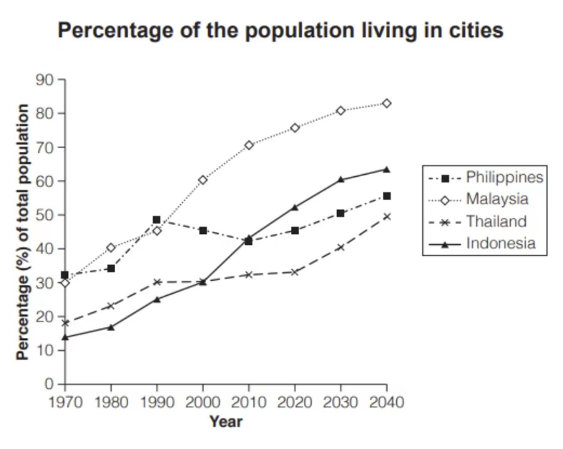

The graph depicts urbanization trends in Thailand, Malaysia, the Philippines, and Indonesia from 1970 to a projection for 2040. In 1970, Thailand had the lowest urban population at about 30%, while Malaysia was highest at nearly 50%. By 2020, Thailand's urban population had risen to approximately 50%, matching Malaysia's 1970 level. The Philippines and Indonesia started around 40% urbanized in 1970 and were near 50% by 2020.

For 2030, projections show Thailand and Malaysia nearing 60% urbanization, with the Philippines just under this mark and Indonesia around 55%. By 2040, Thailand and Malaysia are expected to be close to 70% urbanized, the Philippines around 65%, and Indonesia near 60%.

Thailand's rapid increase from the lowest to one of the highest urban populations suggests a significant shift. Conversely, Malaysia's slower growth indicates a possibly saturated urban population. The Philippines and Indonesia show steady increases, reflecting a gradual urbanization process. These trends may impact urban planning, infrastructure, and socio-economic structures in these countries.

## 43 T18 T2 US households income

The chart below shows the number of households in the US by their annual income in 2007, 2011 and 2015. Summarise the information by selecting and reporting the main features, and make comparisons where relevant.

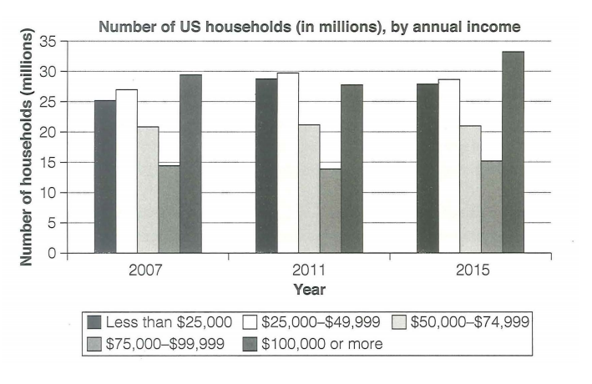

The chart provides a comparative overview of the distribution of US households across different income brackets in the years 2007, 2011, and 2015. In all three years, the majority of households earned less than $25,000 annually, with this group consistently having the highest number of households. The second largest group was those earning between $25,000 and $49,999, followed by those earning between $50,000 and $74,999. The smallest groups were those earning between $75,000 and $99,999 and those earning $100,000 or more.

From 2007 to 2011, there is a noticeable decrease in the number of households in the lowest income bracket (<$25,000) and an increase in the next two higher brackets ($25,000-$49,999 and $50,000-$74,999). This suggests a shift towards higher incomes among some households during this period. However, from 2011 to 2015, the trend reverses slightly for the lowest income bracket, which shows a slight increase, while the other brackets remain relatively stable or show minor fluctuations.

Overall, the data indicates that while there is some movement of households into higher income brackets over time, the majority of households continue to be in the lower income categories. This could reflect economic conditions and income distribution patterns within the US during these years.

## 44 T18 T3 central library ago and now

The diagram below shows the floor plan of a public library 20 years ago and how it looks now.  
Summarise the information by selecting and reporting the main features, and make comparisons where relevant.

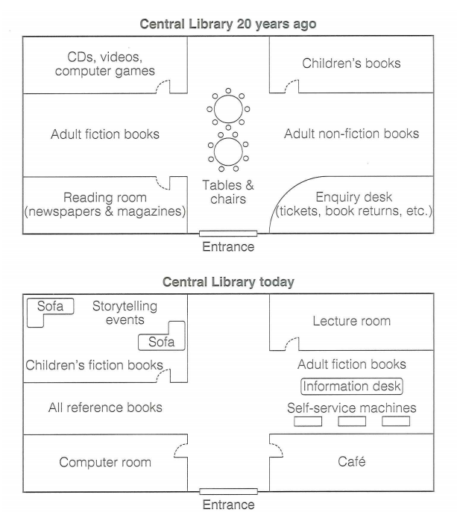

The diagram compares the layout of a public library from two different time points: 20 years ago and today. Both layouts feature an entrance at the bottom center.

In the past, the library had sections for CDs, videos, computer games, adult fiction books, a reading room for newspapers and magazines, tables and chairs for reading or studying, an enquiry desk, adult non-fiction books, and children's books. The current layout includes a café, a storytelling events area, a lecture room, self-service machines, adult fiction books, all reference books, and a computer room.

Changes include the addition of a café and self-service machines, indicating technological advancements and a shift towards more automated services. There is also a new storytelling area and lecture room, suggesting a focus on community engagement and learning. The physical arrangement of book collections has shifted, possibly to accommodate these new features or improve the flow within the library. Overall, the library has evolved to become more interactive and technologically advanced while maintaining its role as a repository of knowledge.

## 45 T18 T4 metals prices change

The graph below shows the average monthly change in the prices of three metals during 2014.  
Summarise the information by selecting and reporting the main features, and make comparisons where relevant.

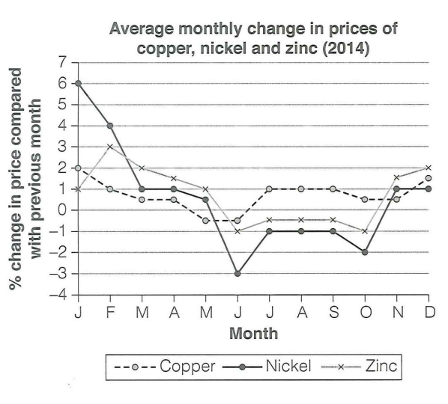

**Title: Average Monthly Price Fluctuations of Copper, Nickel, and Zinc in 2014**

**Introduction:**

The line graph illustrates the average monthly changes in the prices of copper, nickel, and zinc throughout the year 2014.

**Body:**

Beginning with copper, the price trend shows a general increase from January to March, peaking in March. It then experiences a decline until June, followed by a period of relative stability through to the end of the year. Nickel's price pattern is similar to copper's, with an initial rise and a peak in March. However, nickel's decline is more pronounced, reaching its lowest point in August before recovering slightly in the final months. Zinc exhibits a different trend, with a steady increase from January to August, reaching its highest price in August. Post-August, zinc's price drops significantly and then levels off, ending the year at a price similar to its starting point.

**Comparison:**

All three metals show a peak in March, indicating a common market influence during that period. Copper and nickel share a similar decline pattern post-peak, while zinc's peak occurs later, in August. The recovery of copper and nickel's prices in the latter half of the year contrasts with zinc's more consistent decline after August.

(Word Count: ~150)

## 46 T17 T1 industrial area in the town

The maps below show an industrial area in the town of Norbiton, and planned future development of the site.  
Summarise the information by selecting and reporting the main features, and make comparisons where relevant.

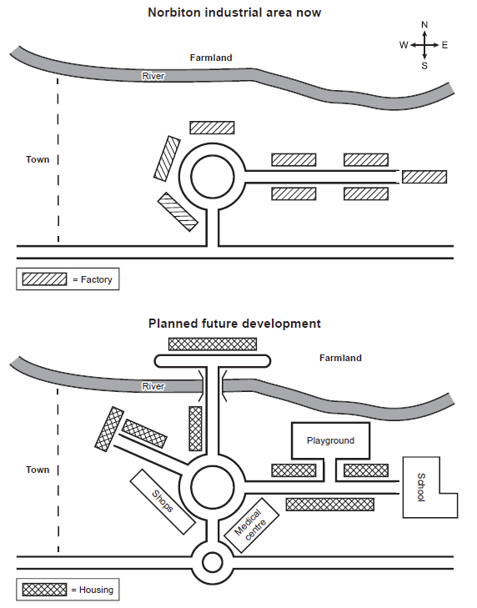

The maps illustrate the current state and planned future development of an industrial area in Norbiton. Currently, the area is divided into three main sections: a factory to the north, farmland to the south, and a river curving from the northwest to the southeast. The factory is depicted as a large rectangular block with diagonal lines, while the farmland is represented by smaller rectangles with crosshatch patterns.

In the planned future development, the factory remains in its current location but is surrounded by new features. To the east of the factory, there is a proposed housing development, indicated by small rectangles with horizontal lines. A playground is planned to the south of the factory, shown as a cluster of rectangles with a star pattern. Additionally, a shopping center is marked to the southwest of the factory, represented by a larger rectangle with a grid pattern. The farmland is repositioned to the west of the factory, maintaining its crosshatch pattern. The overall layout suggests a more integrated urban environment with residential, recreational, commercial, and agricultural zones coexisting within a structured plan that includes the existing river as a natural boundary or feature.

## 47 T17 T2 police budget

The table and charts below give information on the police budget for 2017 and 2018 in one area of Britain. The table shows where the money came from and the charts show how it was distributed.  
Summarise the information by selecting and reporting the main features, and make comparisons where relevant.

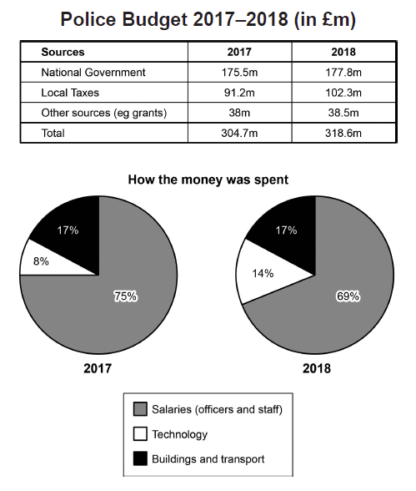

The table and charts provide a comparative overview of the police budget for 2017 and 2018 in one area of Britain. The budget sources are divided into three categories: National Government, Local Taxes, and Other sources (eg grants). In 2017, the total budget was £304.7 million, with £175.5 million from the National Government, £91.2 million from Local Taxes, and £38 million from Other sources. In 2018, the total budget increased slightly to £318.6 million, with £177.8 million from the National Government, £102.3 million from Local Taxes, and £38.5 million from Other sources.

The pie charts show how the money was spent. In both years, the majority of the budget was allocated to Salaries (officers and staff), which accounted for 75% in 2017 and 69% in 2018. Technology received 17% of the budget in 2017 and 14% in 2018, while Buildings and transport received 8% in 2017 and maintained this percentage in 2018.

Comparing the two years, there is a slight decrease in the proportion of the budget allocated to salaries and an increase in the proportion allocated to buildings and transport. This suggests a shift in budget allocation priorities between the two years. Additionally, the overall budget saw a modest increase from 2017 to 2018, with the largest proportional increase coming from Local Taxes.

## 48 T17 T3 weekly spending

The chart below gives information about how families in one country spent their weekly income in 1968 and in 2018.  
Summarise the information by selecting and reporting the main features, and make comparisons where relevant.

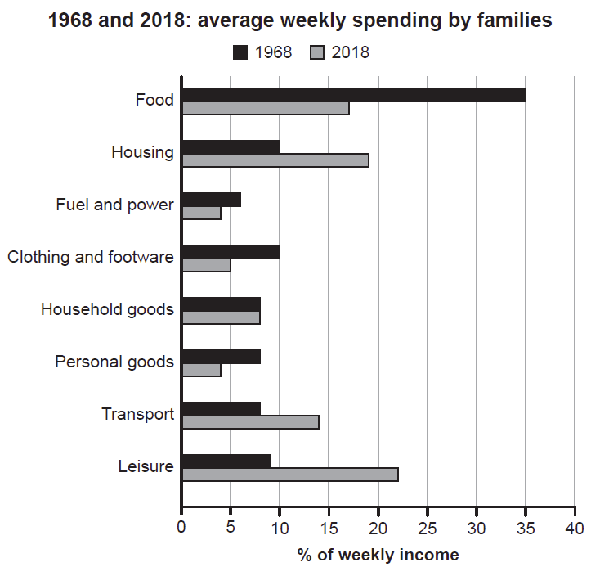

The chart compares the average weekly spending by families in one country between 1968 and 2018. The categories of spending are listed on the y-axis, and the percentage of weekly income spent is represented on the x-axis.

In 1968, food was the largest expenditure, accounting for approximately 35% of the weekly income. Housing followed closely, around 30%. Fuel and power, clothing and footwear, household goods, personal goods, transport, and leisure were the other categories, with leisure being the smallest at about 5%.

By 2018, there was a significant shift in spending patterns. Food remained the highest expenditure but decreased to roughly 25%. Housing increased slightly to nearly 35%, making it the highest expenditure. Fuel and power decreased significantly to around 5%. Clothing and footwear, household goods, and personal goods saw minor fluctuations. Transport increased to approximately 15%, and leisure remained the lowest at about 5%.

Comparing the two years, there is a noticeable decrease in the proportion of income spent on food and an increase in housing costs. The spending on fuel and power decreased significantly, which could be due to changes in energy prices or efficiency improvements over the years. The spending on leisure remained relatively unchanged, suggesting that this category might not have been a priority for most families during these periods.

## 49 T17 T4 shop closed and new started

The graph below shows the number of shops that closed and the number of new shops that opened in one country between 2011 and 2018.  
Summarise the information by selecting and reporting the main features, and make comparisons where relevant.

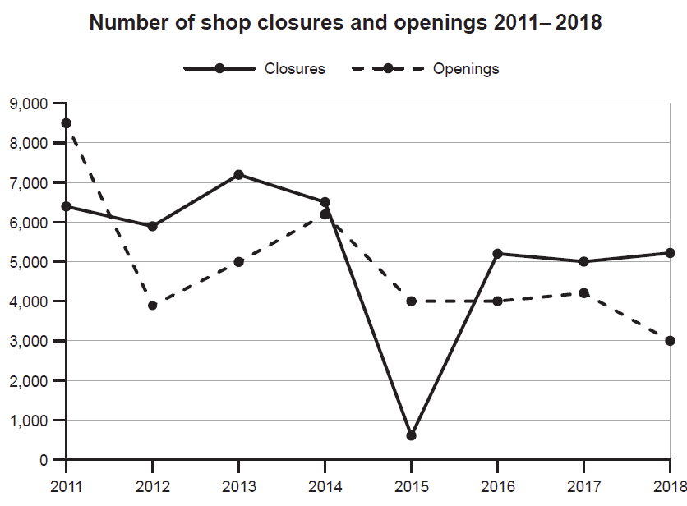

The graph illustrates the trends in shop closures and openings in a country from 2011 to 2018. The number of shop closures is represented by a dashed line, while the number of new shop openings is depicted by a dotted line.

In 2011, there were approximately 9,000 shop closures and around 7,000 new shop openings. From 2011 to 2012, both closures and openings saw a slight decrease. In 2013, there was a sharp increase in closures, peaking at nearly 9,000, while openings remained relatively stable. This peak in closures coincides with a trough in openings, suggesting a challenging year for the retail sector.

From 2014 to 2015, there was a significant drop in closures to about 6,000, accompanied by an increase in openings to around 8,000. This indicates a period of recovery or stabilization in the retail market. However, in 2016, the number of closures surged again to over 8,000, while openings decreased slightly to approximately 7,000.

In 2017, the trend reversed, with closures dropping to around 5,000 and openings increasing to nearly 8,000. This suggests a positive shift in the retail environment. Finally, in 2018, the number of closures increased slightly to approximately 6,000, while openings remained stable at around 7,000.

Overall, the graph shows volatility in the retail sector, with fluctuations in both closures and openings. The years 2013 and 2016 stand out as challenging for retailers, marked by high closures and low openings. Conversely, 2017 appears to be a more favorable year for the industry, with a significant decrease in closures and an increase in openings.

## 50 T16 T1 households with electrical applicances

**The charts below show the changes in ownership of electrical appliances and amount of time spent doing housework in households in one country between 1920 and 2019.**  
  
**Summarise the information by selecting and reporting the main features, and make comparisons where relevant.**

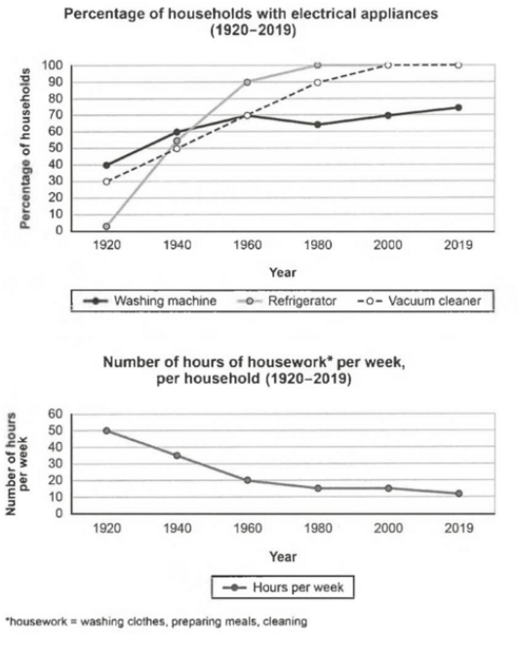

The top chart shows the percentage of households with electrical appliances over a century, from 1920 to 2019. The lines represent three appliances: washing machine, refrigerator, and vacuum cleaner. The trend for all appliances is an upward trajectory, indicating increasing ownership over time. The washing machine line starts at zero in 1920 and reaches nearly 100% by 2019. The refrigerator line also begins at zero in 1920 and climbs steadily, reaching approximately 80% by 2019. The vacuum cleaner line starts later, around 1960, and rises sharply to about 70% by 2019.

The bottom chart depicts the number of hours spent on housework per week per household from 1920 to 2019. The line representing the number of hours per week starts at around 60 hours in 1920 and declines gradually over the years, reaching close to 20 hours by 2019. This suggests a significant reduction in the amount of time dedicated to housework over the century.

Comparing the two charts, there is a clear correlation between the increasing ownership of electrical appliances and the decreasing time spent on housework. As more households acquired appliances that automate tasks like washing clothes and preparing meals, the overall time devoted to these chores decreased. This indicates a shift in lifestyle andhousework management facilitated by technological advancements.

## 51 Pie chart household expenditures

The pie charts below show the average household expenditures in Japan and Malaysia in the year 2010.

Summarise the information by selecting and reporting the main features, and make comparisons where relevant..

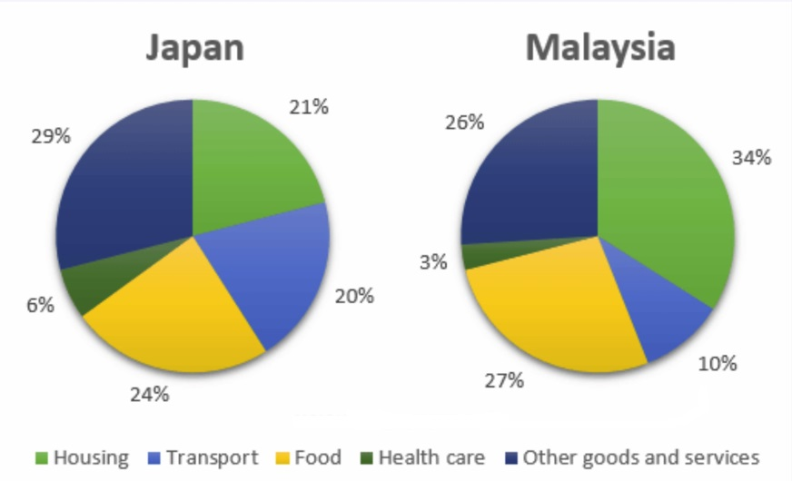

The pie charts show the proportion of money spent on various household expenses in Malaysia and Japan in 2010.

We can see that in Malaysia the greatest proportion of expenditure (34%) was on housing,in Japan housind

accounted for just 21% of the total. ..., in Japan the greatest single expense was other goods and services at 29%,... 6% in Malaysia. Food came in second place in Japan, at 24% hile in Malaysia the actual proportion was ..

.... (27%). In apan another major expense was transport, at 20%, but this as much....... In Malaysia (10%). In both countries the.... ercentage of expenditure was on health care.

......., the data.......that in both cases food,housing and other goods and services were the.... expenses, .... that in Japan,transport and other goods and services took up a... proportion of total expenditure ...... in Malaysia.

## 52. passed high school competency exams

The bar chart below shows the percentage of students who passed their high school competency exams, by

subject and gender, during the period 2010-2011.

Summarise the information by selecting and reporting the main features, and make comparisons where relevant.

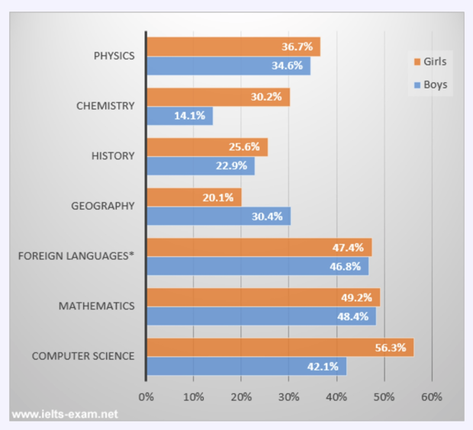

The bar chart provides a comparative overview of the percentage of students who passed their high school competency exams in various subjects, segmented by gender. The subjects included are Physics, Chemistry, History, Geography, Foreign Languages, Mathematics, and Computer Science.

In Physics, boys have a higher pass rate at 34.6%, compared to girls at 36.7%. In Chemistry, boys again have a slightly higher pass rate at 30.2% than girls at 14.1%. For History, boys have a pass rate of 22.9%, while girls are at 23.6%. In Geography, boys have a pass rate of 20.1%, which is equal to that of girls.

For Foreign Languages, there is a notable difference with girls having a significantly higher pass rate at 47.4%, compared to boys at 46.8%. In Mathematics, boys have a slight edge over girls with a pass rate of 49.2% versus 48.4%. Lastly, in Computer Science, boys have a higher pass rate at 56.3%, whereas girls are at 42.1%.

Overall, the data suggests that boys tend to perform better in the sciences and mathematics, while girls show stronger performance in foreign languages. There is no significant difference in History and Geography. These trends may reflect societal influences, educational approaches, or inherent differences in subject interests between genders.

## 53 books read by men and women

The graph below shows the number of books read by men and women at Burnaby Public Library from 2011 to 2014.Summarise the information by selecting and reporting the main features, and make comparisons where relevant. 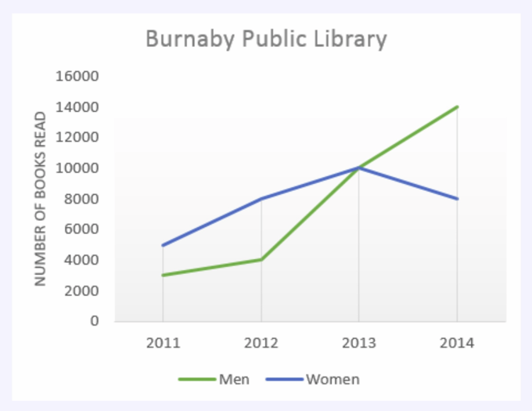

The graph illustrates the reading habits of men and women at the Burnaby Public Library over a four-year period from 2011 to 2014. In 2011, both genders read approximately the same number of books, with men reading slightly more. However, in 2012, there is a notable increase in the number of books read by women compared to men. This trend continues through 2013, with women consistently reading more books than men. By 2014, the gap between the two groups widens significantly, with women reading nearly double the number of books as men.

This data suggests that over these years, there was a growing disparity in reading habits between men and women at the Burnaby Public Library, with women becoming more active readers relative to men. The reasons for this trend are not provided in the graph, but it could be indicative of various factors such as changes in leisure activities, educational trends, or library programming that may have appealed more to one gender over the other.

## 54 changes taken place at Queen Mary Hospital

The diagrams below show the changes that have taken place at Queen Mary Hospital since its construction in 1960.Summarise the information by selecting and reporting the main features, and make comparisons where relevant.

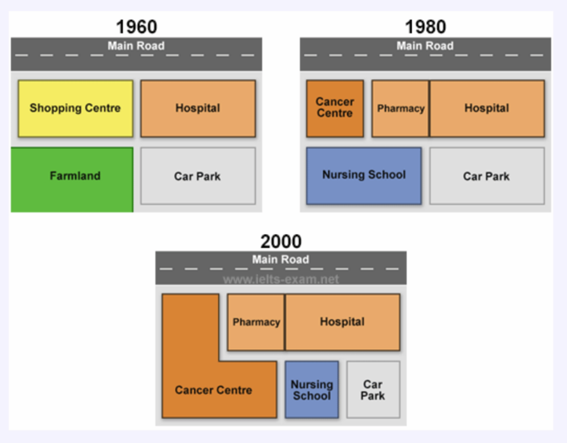

The diagrams show Queen Mary Hospital at three different stages in its development: 1960, 1980 and 2000.In 1960, the hospital was built close to a main road and next to a shopping centre. A large area behind the hospital was turned into a car park, while the area behind the shopping center was farmland.By 1980, the shopping centre had been demolished in order to make way for two additional hospital building which became a pharmacy and a cancer centre. Furthermore, the hospital gained the farmland and converted it into a nursing school.In 2000, the main hospital building remained unchanged but the cancer centre was extended to cover the entire nursing school.As a result of this, the original car park was divided into two so that it provided a smaller car park and a small nursing school.During this period, the hospital has increased in size and, in addition to a new nursing school, a cancer centre has been created and extended. Hence the capacity of the car park has been reduced by a half.

## 55 tourists to England who visited attractions

The line graph below shows the percentage of tourists to England who visited four different attractions in Brighton.

Summarise the information by selecting and reporting the main features, and make comparisons where relevant.

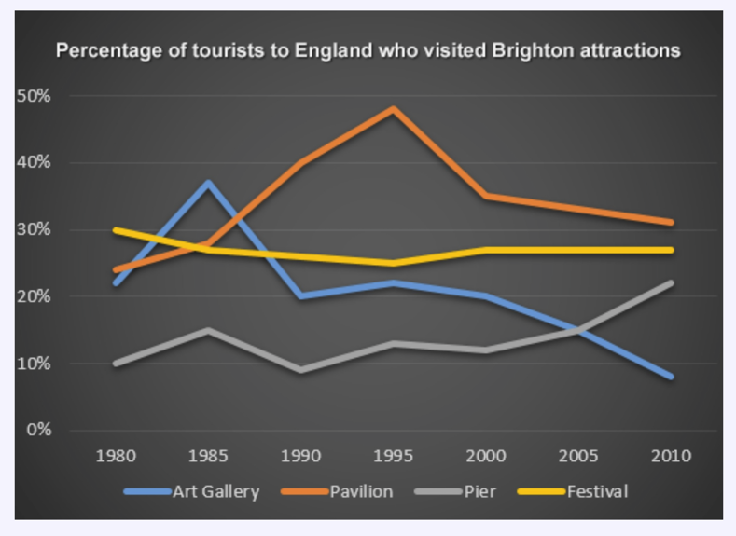

The line graph shows the percentage of tourists to England whovisited certain Brighton attractions between 1980 and 2010. Wecan see that in 1980 and in 2010 the favourite attractions werethe pavilion and the festival. In 1980 the least popular attractionwas the pier but in 2010 this changed and the art gallery was theleast popular.During the 1980s and 1990s there was a sharp increase invisitors to the pavilion from 28% to 48% and then the percentagegradually went down to 31% in 2010. The trend for the art gallerywas similar to the pavilion. Visitors increased rapidly from 22%to 37% from 1980 to 1985 then gradually decreased to less than10% over the next twenty-five years. The number of tourists whovisited the Brighton Festival fluctuated slightly but in generalremained steady at about 25%. Visitors to the pier also fluctuatedfrom 1980 to 2000 then rose significantly from 12% to 22%between 2000 and 2010.

## 56 employment patterns in Great Britain

The two pie charts below show some employment patternsin Great Britain in 1992.Summarise the information by selecting and reporting themain features, and make comparisons where relevant..

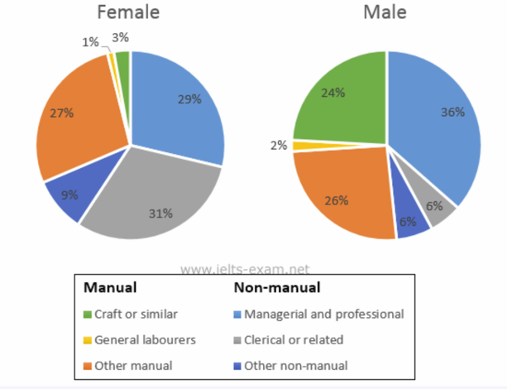

The charts provide information on the proportion of malesand females in employment in 6 broad categories, divided intomanual and non-manual occupations. In general, a greaterpercentage of women work in non-manual occupations than workin manual occupations, and the reverse is true for men.In the non-manual occupations, while a greater percentage ofworking women than men are found in clerical-type positions,there is a smaller percentage of women than men employed inmanagerial and professional positions. The percentage of womenemployed in other non-manual occupations is slightly larger thanthe percentage of men in these occupations.In manual employment, the biggest difference between the twosexes is in the employment of craft workers, where males makeup 24% of the workforce and females just 3%. Furthermore, thepercentage of women working as general working as generalabourers is very small, only 1%. There is not a great deal ofdifference between the percentage of men doing other forms ofmanual work (26%) and women in other manual work (27%).In summary, the two charts clearly show that women do not havethe same access as men to certain types of employment.

## 57 production of electricity using Ocean Thermal Energy Conversion

The diagram below shows the production of electricityusing a system called Ocean Thermal Energy Conversion(OTEC).Summarise the information by selecting and reporting themain features, and make comparisons where relevant..

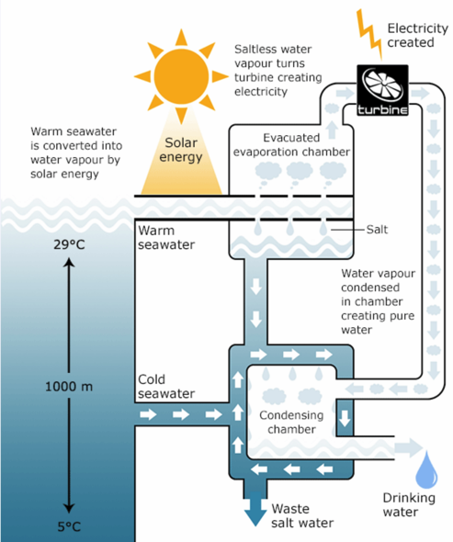

Ocean thermal energy conversion (OTEC) is a system thatconverts heat energy into the electric power using thetemperature difference between surface seawater, which canbe up to 29 degrees Celsius, and deep seawater, which is only 5degrees Celsius.The main components of the system are an evacuatedevaporation chamber, a turbine and a condensing chamber.The solar energy of the sun heats up the surface water andthis warm water is introduced into the evacuated evaporationchamber, where it boils. As it boils, salt is deposited and watervapour is generated. This vapour then drives a turbine to generateelectricity. After it powers the turbine, the water vapour entersthe condensing chamber, which is cooled by the water fromthe depths of the ocean. The water vapour is condensed in thischamber, producing drinking water. Meanwhile, waste salt wateris discharged into the ocean and the process can be repeated.

## 58 travelers using three major airports

The chart below shows the number of travellers usingthree major airports in New York City between 1995 and2000.Summarise the information by selecting and reporting themain features, and make comparisons where relevant..

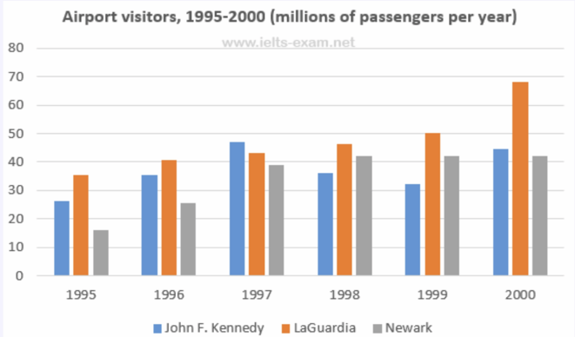

The bar chart gives information about how many people visitedNew York City through three major airports, over a six-year periodbetween 1995 and 2000.Overall, it can be seen that over the period, there was a fluctuanttrend in the number of passengers who travelled via John F.Kennedy airport, while the other two airports saw an upwardtrend. Another interesting point is that LaGuardia airport was themost popular at the end.Looking at the detail, the number of travellers at John F. Kennedyairport started at 26m in 1995, and then increased remarkably toreach the highest point of 47m in 1997. In 1999, the figure dippedto 32m. At the last year, there was a slight growth to 44m. On theother hand, LaGuardia began at 35m in 1995, after that it roseremarkably for the next three years, at 46m. In 2000, LaGuardiahit the peak point at 68m travellers.However, if we look at Newark airport, it started at the lowestpoint of 16m passengers in the first year. After this point, thetrend increased significantly to 42m in 1998. In the last two yearsit remained stable at 42m travellers.

## 59 changes in the share price

The line graph below shows the changes in the share priceof Outokumpu companies in euros between January 2006and December 2010.Summarise the information by selecting and reporting themain features, and make comparisons where relevant..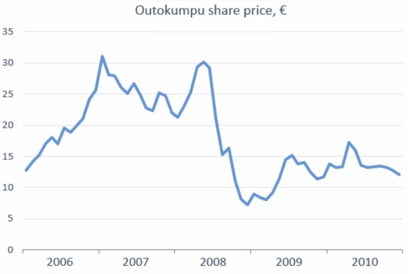

The graph shows the changes and a decline overall in the shareprice of Outokumpu in a five-year period from January 2006through December 2010.At the beginning of this period the share price was at EUR 13 pershare. There were several fluctuations until late 2006 when therewas a sudden increase from EUR task_21 to EUR 31. This higherprice did not last long, however, and it fell before rising stronglyagain in 2008. From mid-2008 there was a sharp downward trendthrough the end of the year when it fell to the lowest point in thisperiod at just over EUR 7 per share. After that the share pricerecovered and,despite some fluctuations, continued to rise untilit reached a peak of EUR 17 in early 2010. Until late 2010 thetrend was downward again,ending the year at just over EUR 12Outokumpu made significant gains and losses during this periodbut overall lost around EUR 1 per share.

## 60 female unemployment rates

The graph below shows female unemployment rates ineach country of the United Kingdom in 2013 and 2014.Summarise the information by selecting and reporting themain features, and make comparisons where relevant..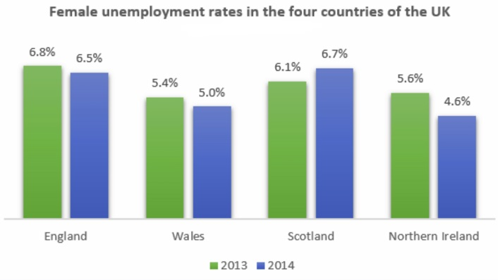

The bar chart shows the unemployment rates among women inthe countries that make up the United Kingdom, both in 2013 andin 2014. There has generally been a small decrease in femaleunemployment rates from 2013 to 2014, except in Scotland.In 2013,5.6% of women in Northern Ireland were unemployed.The only country with a smaller percentage of womerunemployed was Wales, with a rate of 5.4%. Both countries sawa decrease in the percentage of unemployed women in 2014. InNorthern Ireland, the percentage fell to 4.6% and in Wales it fell to5%.England had the greatest percentage of unemployed womenin 2013, with 6.8%. However, this decreased by 0.3% in 2014.Lastly, Scotland was the only country which had an increasingpercentage of unemployed women. In 2013, it had 6.1% ofwomen out of work. This increased to 6.7% in 2014, making it thecountry with the highest female unemployment rate of the fourcountries.

## 61 online sales for retail sectors in Canada

The two pie charts below show the online shopping salesfor retail sectors in Canada in 2005 and 2010.Summarise the information by selecting and reporting themain features, and make comparisons where relevant..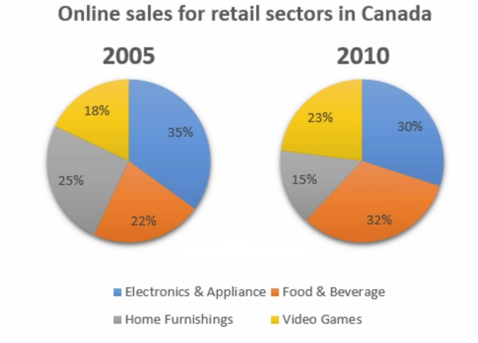

The two pie charts compare the percentages of online salesacross different retail sectors in Canada in the years 2005 and2010. For three of the sectors, it is evident that over this timeframe there was significant change in their proportion of onlinetransactions.At 35% we can see that electronics and appliance sectoraccounted for the majority of online sales in 2005, but thispercentage had dropped to 30% by 2010. During the samepurchase food and beverage online, we can see that transactionsfive-year period, as an increasing number of people chose towent from just 22% to 32%, making it the retail sector with thelargest overall proportion of the online market.In 2005, the home furnishing industry boasted an impressive 25%of the total online sales in Canada. However, by 2010, the figurehad fallen considerably to 15%. Interestingly, online sales of videogames eventually overtook sales of home furnishings, althoughvideo games still represented only 23% of the market

## 62 changes in annual spending

The three pie charts below show the changes in annualspending by local authorities in Someland in 1980,1990and 2000.Summarise the information by selecting and reporting themain features, and make comparisons where relevant..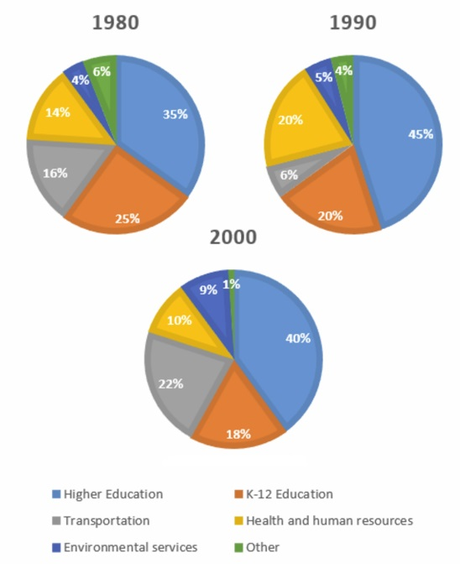

The charts show how much local authorities spent on a rangeof services in Someland in three separate years: 1980, 1990 and2000.In all three years, the greatest expenditure was on education.But while K-12 education saw a fall from 25% in 1980 to only18% of spending in 2000, higher education remained the largestproportion, reaching 45% of total spending in 1990 and ending at40% in 2000.Expenditure on health and human resources had increased to20% by 1990 before decreasing to only 10% by the end of theperiod. In contrast, the share of transportation saw an oppositetrend. This cost decreased to only 6% of total expenditure in 1990but rose dramatically in 2000 when it represented 22% of the totalbudget. Similarly, the cost of environmental services saw a risingtrend, growing from only 4% tо 9% by 2000.Overall, higher education constituted the largest cost to localauthorities, and while spending increased for transportationand environmental services, there were corresponding drops inexpenditure on health and human resources and K-12 education.

## 63 money spent on books

The graph below shows the amount of money spent onbooks in Germany, France, Italy and Austria between 1995and 2005.Summarise the information by selecting and reporting themain features, and make comparisons where relevant..

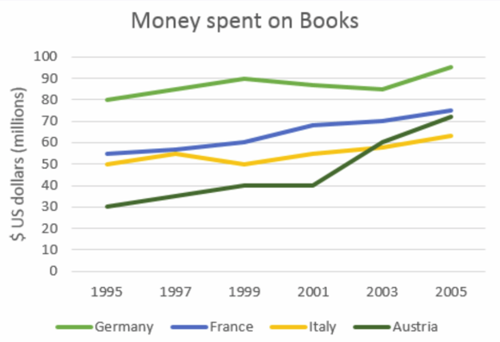

The graph illustrates the expenditure on books in millions of US dollars across four European countries—Germany, France, Italy, and Austria—over a decade from 1995 to 2005. Germany consistently shows the highest spending on books throughout the period, with an upward trend that peaks around 2003 before slightly declining by 2005. France's spending is the second highest, with a steady increase until 2001 followed by a plateau and a slight decrease thereafter. Italy's expenditure starts lower than France but shows a more pronounced increase over time, surpassing France's spending after 2003. Austria has the lowest spending among the four, with a modest increase over the years.

In summary, Germany leads in book spending, followed by France, Italy, and Austria. All countries show an overall increase in spending over the decade, with Germany and Italy exhibiting more significant growth compared to France and Austria.

The line graph compares the amount of money spent on buyingbooks in Germany, France, Italy and Austria over a period of tenyears between 1995 and 2005.In 1995 Austria spent the.... amount of money on bookswhile Italy and France spent about as........ as each other.However, by 2001, the gap in spending between these twocountries had widened and considerably........ money was spentin France than In Italy.As can be seen from the graph, the amount of money spentincreased in all four countries but rose the most ....... inAustria. The period between 2000 and 2005 saw a ........ growthand in 2005 the Austrians spent ....... s much money as theydid in 1995.However, during this ten-year period, Germany remainedthe ...... spenders on book, with all three other countriesspending much....... on them.

## 64 population change in U.S. state of Oregon

The graph below shows the population change between1940 and 2000 in three different counties in the U.S. stateof Oregon.Summarise the information by selecting and reporting themain features, and make comparisons where relevant..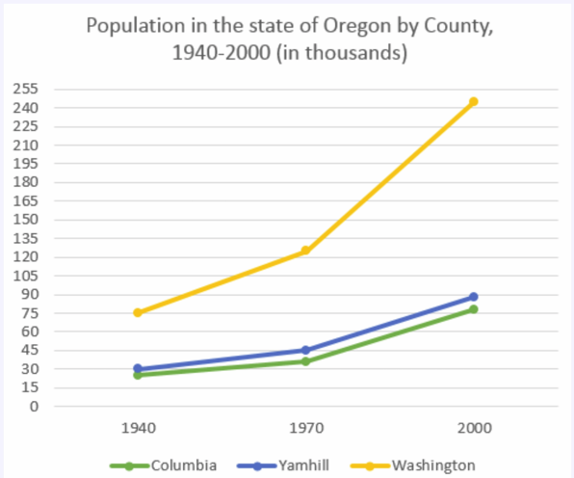

The graph shows the increase in population of three counties,Columbia, Yamhill and Washington in the U.S. state of Oregon,between 1940 and 2000. In 1940, Columbia had the lowestpopulation of the three counties, at around 25,000. Thiscompared with about 30,000 in Yamhill and approximately 75,000in Washington.By 1970, Columbia's population had risen to just under 36,000.Although this appears on the graph to be a gentle increase, it isin fact an increase of approximately 50%. Yamhill's populationalso rose by nearly 50% between 1940 and 1970: from 30,000to just under 45,000. However, the greatest real increase wasin Washington, where the population in 1970 had increased byapproximately 75,000, to 125,000.The years 1970 to 2000 saw the populations of Columbia andYamhill increase by approximately the same amounts that theyhad increased by the thirty years before. In 2000, Columbia'spopulation - at approximately 76,000- was triple what it hadbeen in 1940. Likewise, Yamhill's population, at around 90,000,was almost triple what it was in 1940.Although Washington's increase in population between 1940 and1970 was large, its increase in the following thirty years was evensharper, rising from about 125,000 in 1970 to more than 240,000in 2000.

## 65 changes in food consumption by Chinese people

The graph below shows the changes in food consumptionby Chinese people between 1985 and 2010.Summarise the information by selecting and reporting themain features, and make comparisons where relevant..

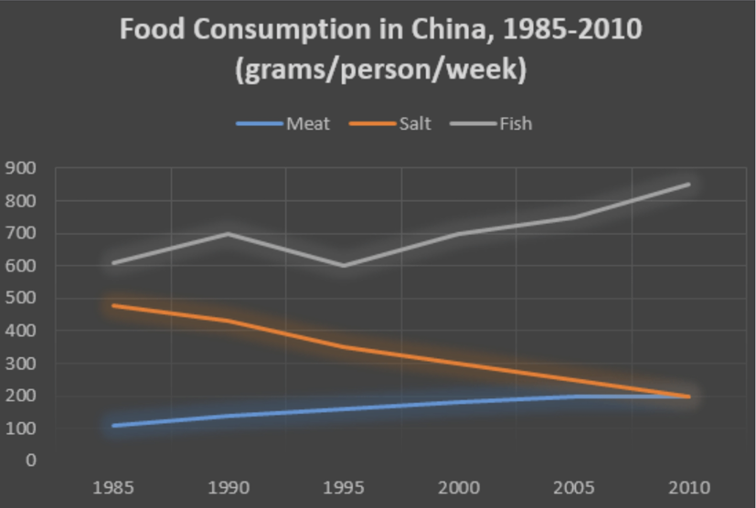

The graph shows changes in the amount of fish, salt andmeat eaten per person per week in China between 1985 and2010.In 1985, the consumption of fish stood at 610 grams,then increased to 700 grams in 1990.The amount consumeddecreased steadily from almost 500 grams per person to only 200grams by 2010.However, this gradually increased throughout the period.Overall,the consumption of fish rose, while the consumption of saltfell.The amount of meat consumed weekly started at about 100grams.From the graph we can see that people in China consumedmore fish than either meat or salt throughout the period.By 2010 it was at the same level as the consumptionof salt.In contrast, there was a consistent drop in saltconsumption.Although it dipped in 1995, it then rose steadily andreached 850 grams in 2010.In addition, the consumption of meat,while at a relatively Iow level, rose significantly during this period.

## 66 percentages who watch two genres of TV shows

The charts give information about two genres of TVprogrammes watched by men and women and fourdifferent age groups in Australia. 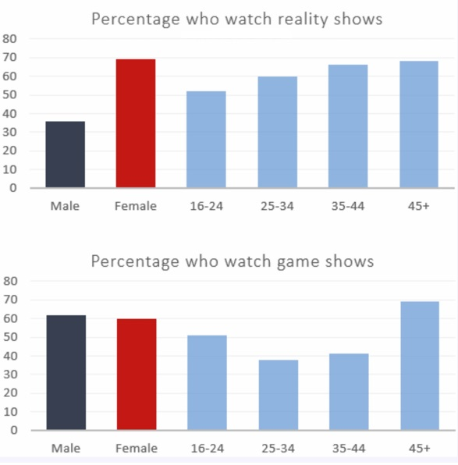

The bar charts provide data on the percentage of viewership for two genres of TV programs—reality shows and game shows—across different demographics in Australia. For reality shows, the chart shows that women have a higher percentage of viewership than men across all age groups. The youngest age group (16-24) has the highest viewership among women at nearly 70%, while men in this age group have a viewership of about 30%. As age increases, the viewership percentages for both genders decrease, with the lowest viewership among those aged 45+.

For game shows, the pattern is similar, with women again having higher viewership percentages than men across all age groups. However, unlike reality shows, the viewership percentages are more evenly distributed across age groups, with the highest viewership among those aged 45+ at approximately 70% for women and 60% for men. The lowest viewership is among the youngest age group (16-24), with around 30% for women and 40% for men.

Overall, the data suggests that women in Australia tend to watch more reality and game shows than men, and that older individuals (45+) have a higher viewership of game shows compared to younger age groups.

## 67 new school planned for the town

The map below is of the town of Canterbury. A new school(S) is planned for the area. The map shows two possible sites for the school.

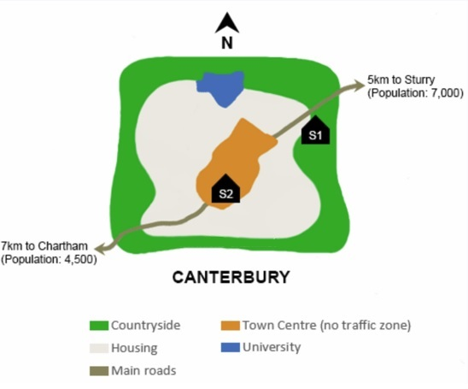

The map shows two proposed sites for a new school for the townof Canterbury and the surrounding area.The first site (S1) is situated in the countryside, to the north-eastof the town centre. It is just outside the main housing area ofthe town and not far from the main road that links Sturry withCanterbury. It would therefore probably be in an ideal location forstudents coming from Sturry, which is only 5 kilometres away,and those who live on the east side of Canterbury. If there arestudents coming from Chartham, which is 7 kilometres to thesouth-west, they would be able to reach the school by taking themain road that runs south-west of Canterbury.The second site (S2) is located in the town centre itself. There areadvantages of this: it makes it practically equidistant for studentscoming from either Sturry or Chartham. Moreover, it wouldpresumably be relatively easy for students who live in the housingarea around the town centre to reach the school. However,because of the no traffic zone in the town centre, no parent wouldbe able to drive their child all the way to school. This may maketravel arrangements difficult for some parents.

## 68 Expenditures for five major categories

The bar chart below shows shares of expenditures for five major categories in the United States, Canada, the United Kingdom, and Japan in the year 2009.Write a report for a university lecturer describing the information below.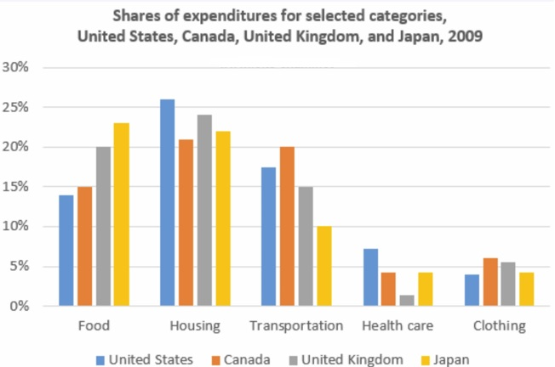

The bar chart provides a comparative overview of expenditure shares in five major categories across four countries. The United States, Canada, the United Kingdom, and Japan are compared in terms of their spending on food, housing, transportation, health care, and clothing.

In the category of food, the United States and Canada show similar expenditure shares, which are slightly higher than those of the United Kingdom and Japan. Housing expenditures are highest in the United Kingdom, followed by the United States, Canada, and Japan. Transportation costs are also notably higher in the United Kingdom compared to the other three countries. Health care expenses are highest in the United States, significantly surpassing those of the other countries. Lastly, clothing expenditures are lowest in Japan, with the United Kingdom showing the highest share among the four nations.

This data could be useful for economists, policymakers, or researchers interested in comparing living costs and consumer behavior across these developed countries. It may also serve as a basis for discussions on economic disparities, standard of living, and the impact of cultural differences on consumer expenditure patterns.

## 69 international students among university graduates

The chart below shows the percentage change in the shareof international students among university graduates indifferent Canadian provinces between 2001 and 2006.Summarise the information by selecting and reporting the mainfeatures, and make comparisons where relevant.

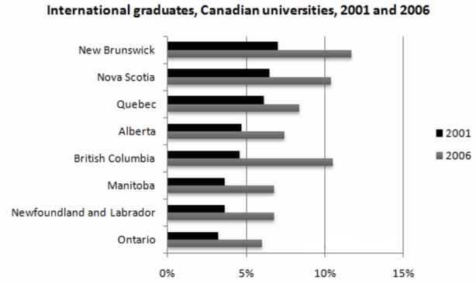

The chart shows changes in the share of international studentswho graduated from universities in different Canadian provincesover a period of 5 years.In 2001,this share had a relatively narrow range, from 3% inOntario to 7.0% in New Brunswick. Nova Scotia had the secondhighest proportion at 6.5%. Five years later, the figures for mostprovinces had risen, with the exception of Alberta. There, thefigures fell by 1% to just over 4%.By 2006, some parts of Canada experienced a considerableincrease in their share of international graduates. Growth in thisshare was especially strong in the case of New Brunswick, wherethe figures rose from 7% to 12%. The largest growth occurred inBritish Columbia,where it more than doubled to 11%.Over this five-year period, changes in the proportion ofinternational graduates have been very uneven across theprovinces of Canada. However, New Brunswick remained theprovince with the highest percentage overall.

## 70 wave generated electricity

Summarize the information by selecting and reporting the mainfeatures, and make comparisons where relevant.

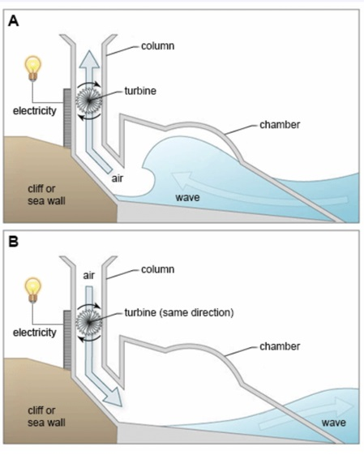

The two diagrams show how electricity can be generated fromthe rise and fall of water caused by sea waves.The process involves a structure which is mounted on the side ofa cliff or sea wall. This structure consists of a large chamber. Oneend is open to the sea, and the other leads into a vertical column,which is open to the atmosphere. A turbine is installed inside thiscolumn and this is used to generate the electricity in two phasesThe first diagram indicates that when a wave approaches thedevice, water is forced into the chamber, applying pressure on theair within the column. This air escapes to atmosphere throughthe turbine, thereby producing electricity.when wave retreats. As the water level falls, the air from outsideThe second diagram illustrates the next part of the processthe column is sucked back in through the turbine. As a result,electricity continues to be generated. The turbine rotates only inone direction, regardless of the direction of the air flow.In conclusion, we can see that this structure is useful aselectricity is generated in both phases: entering and retreating of water.

## 71. reasons why people work by bicycle or by car

The charts below show the reasons why people travel to work by bicycle or by car.Summarize the information by selecting and reporting the main features, and make comparisons where relevant.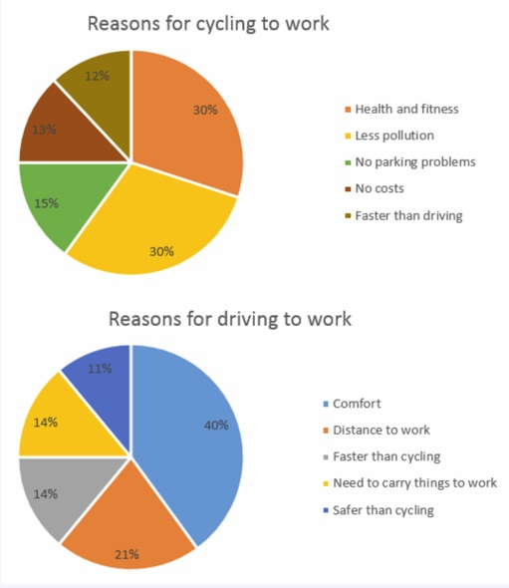

The first chart shows the reasons why some people in the UK prefer to cycle to work. Conversely, the second chart gives reasons for those who choose to go to work by car.

The highest percentage of those who favour cycling say that this is because riding a bicycle to work is healthier than driving. 30% of them gave this as a reason. The same amount of people, 30% say that they cycle to work because it causes less pollution. 13% of people cycle to work because it is cheaper than driving. Surprisingly, a similar amount of people said that they cycled to work because it is faster than travelling by car.

In contrast to this, the percentage who prefer to travel by car because it is more comfortable is 40%. The two least important reasons for going to work by car, with 14% and 11% respectively, is that people need to carry things to work and that it is safer than cycling to work. Finally,16% say they prefer driving because it is faster than cycling. This contrasts with the cyclists who ride to work because it is faster than driving.

In general, it seems that the majority of people who cycle to work do this for health and environmental reasons. By contrast, those who travel by car want to have a more comfortable journey over longer distances.

## 72 population growth in India and China

The graph below shows population figures for India and China since the year 2000 and predicted population growth up until 2050.Summarise the information by selecting and reporting the main features, and make comparisons where relevant.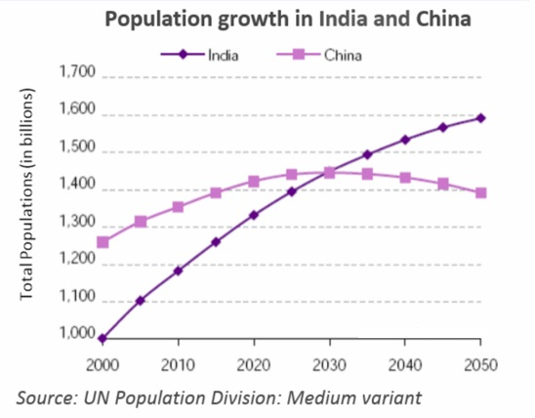

The graph shows how the populations of India and China have changed since 2000 and how they will change in the future.

In 2000, there were more people living in China than in India. The number of Chinese was 1.25 bill ion, while India's population was about 1 billion. Between 2000 and the present, there has been a 0.2 billion rise in the number of Indian citizens. Over the same period, China's population has increased by 0.1 billion to reach over 1.35 billion.

According to the graph, the population in India will increase more quickly than in China, and experts say that by 2030, both countries will have the same population of 1,45 billion. After this China's population is likely to fall slightly to 1.4 billion in 2050, while India's population will probably increase and reach 1.6billion.

Thus, over the 50-year period, India is going to experience steady growth in its population and it will overtake China. On the other hand, China's population will peak in 2030 and then begin to fall.

## 73 languages with the most native speakers

The table below gives information about languages with the most native speakers.Summarise the information by selecting and reporting the main features, and make comparisons where relevant.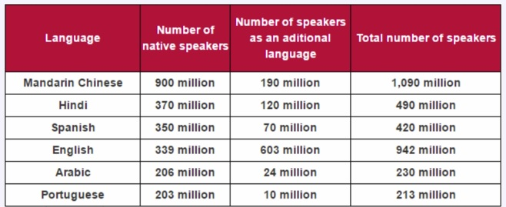

The table illustrates the number of native speakers of six languages as well as the number of speakers of these languages as an additional language. It is noticeable that the number of speakers of Mandarin Chinese is strikingly higher than the other languages with over one billion speakers.

People who speak Mandarin largely speak it as a first language (900 million). In comparison to this only 190 million people speak Mandarin Chinese as an additional language. What is remarkable about English speakers is that the number of speakers of English as an additional language is higher than that of native speakersof English (603 and 339 million respectively).

While the total number of Hindi speakers (490 million) is roughly equal to that of Spanish speakers (420 million); when it comes to speaking these languages as an additional language the number for Hindi is much higher (120 million) than that for Spanish (70 million).

Native speakers of Arabic and Portuguese are similar in number with 206 million and 203 million respectively. However, the number of Arabic speakers as an additional language (24 million) is almost 2.5 times higher than speakers of Portuguese as an additional language

## 74 restaurant’s average sales

The table below gives information about a restaurant's average sales in three different branches in 2016.Summarize the information by selecting and reporting the main features, and make comparisons where relevant.

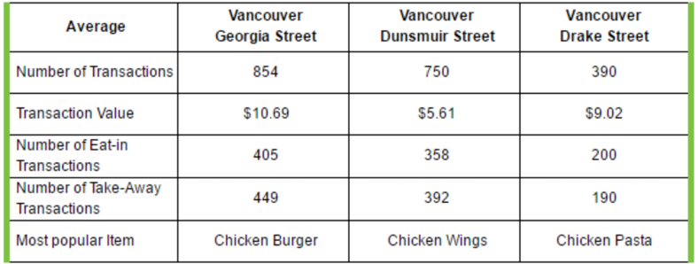

The table illustrates the performance of three different branches of a chain of restaurants in three different locations in Vancouver for the year 2016. lt is evident that the best performer is the branch in Georgia Street, which with 854 transactions a day on average has at least 100 more transactions than Dunsmuir Streetand more than double from Drake Street. Georgia Street is also ahead in terms of average transaction value (ATV), with $10.69 per transaction compared to Dunsmuir Street's $5.61 and DrakeStreet's $9.02.

On average, eat-in and take-away transactions are almost equal in each restaurant, with take-away transactions ending slightly ahead in two of them. Drake Street is the only exception, with eat-in transactions surpassing take-away by 10.

The table also gives us information about the most popular item in each branch, revealing that the eating habit of customers in each area are widely varied: Georgia Street's best seller is Chicken Burger, while Dunsmuir Street's customers favor Chicken Wings, and Drake Street's customers prefer Chicken Pasta.

Overall, it is clear that the Georgia Street's branch is the company's most profitable branch, with the highest number of transactions and ATV. Drake Street, on the other hand, lags far behind, despite the fact that its ATV is higher than Dunsmuir Street.

## 75 agricultural land becomes less productive

The pie chart below shows the main reasons why agricultural land becomes less productive. The tableshows how these causes affected three regions of the world during the 1990s.Summarise the information by selecting and reporting the main features, and make comparisons where relevant.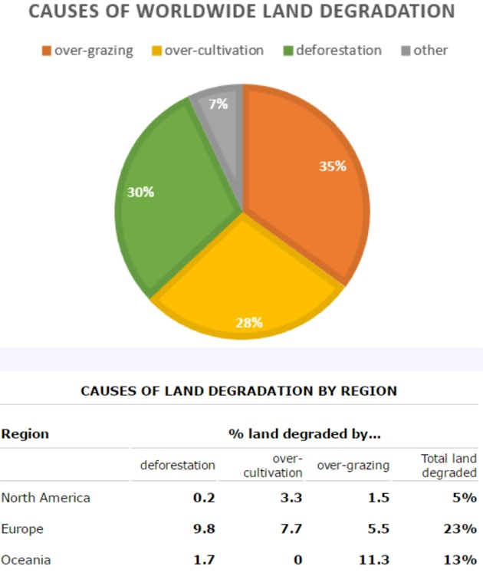

The pie chart shows that there are four main causes of farmland becoming degraded in the world today. Globally, 65% of degradation is caused by too much animal grazing and tree clearance, constituting 35% and 30% respectively. A further 28% of global degradation is due to over-cultivation of crops. Other causes account for only 7% collectively.

These causes affected different regions differently in the 1990s, with Europe having as much as 9.8% of degradation due to deforestation, while the impact of this on Oceania and North America was minimal, with only 1.7% and 0.2% of land affected respectively. Europe, with the highest overall percentage of land degraded (23%), also suffered from over-cultivation (7.7%) and over-grazing (5.5%). In contrast, Oceania had 13% of degraded farmland and this was mainly due to over-grazing (11.3%). North America had a Iower proportion of degraded land at only 5%, and the main causes of this were over-cultivation (3.3%) and, to alesser extent, over-grazing (1.5%).

Overall, it is clear that Europe suffered more from farmland degradation than the other regions and the main causes there were deforestation and over-cultivation.

## 76 pollution levels in London between 1600 and 2000

The graph below shows the pollution levels in London between 1600 and 2000.Summarize the information by selecting and reporting the main features, and make comparisons where relevant.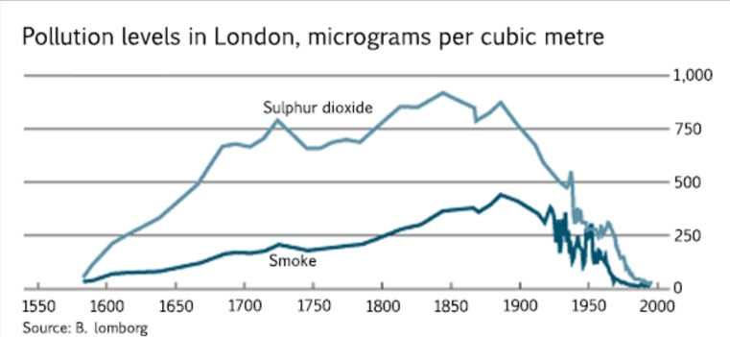

(1st paragraph introduces the topic of the graph, explains whatthe graph shows and outlines overall trends or patterns.)The graph shows pollution levels in London between 1600 and 2000. It measures smoke and sulphur dioxide in micrograms per cubic meter. According to the information, the levels of both pollutants formed a similar pattern during this period, but there were always higher levels of sulphur dioxide than smoke in the atmosphere.

(2nd paragraph describes the trends in more detail and illustratesthese using data from the graph.)In 1600, pollution levels were low, but over the next hundred years, the levels of sulphur dioxide rose to 700 micrograms per cubic meter, while the levels of smoke rose gradually to about 200 micrograms per cubic metre. Over the next two hundred years the levels of sulphur dioxide continued to increase although there was some fluctuation in this trend. They reached a peak in 1850. Smoke levels increased a little more sharply during this time and peaked in 1900 at about 500 micrograms. During the 20th century, the levels of both pollutants fell dramatically though there was a great deal of fluctuation within this fall.

(Final paragraph draws a simple conclusion from the data.)Clearly air pollution was a bigger problem in London in the early 20th century than it is now.

## 77 sales of Fairtrade-labelled tea

The tables below give information about sales of Fairtrade*-labelled tea and pineapples in 2010 and 2015 in five European countries.Summarize the information by selecting and reporting the main features, and make comparisons where relevant.

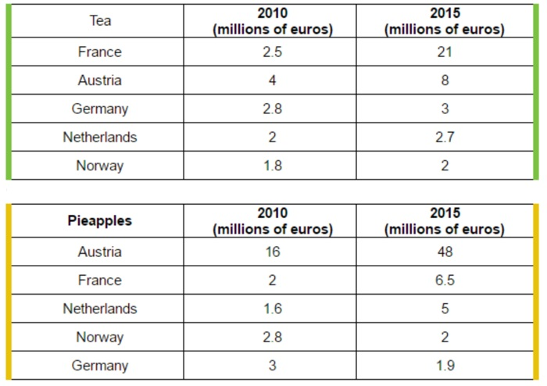

The two tables contain sales data for Fairtrade tea and pineapples in 2010 and 2015, in five nations of Europe.

The first table shows low-level tea sales increasing in all five countries, albeit to widely varying degrees. In two places sales increased by the same small amount: 2.8-3 million euros in Germany, and 1.8-2 million in Norway. The increment was slightly larger in Netherlands, from 2-2.7 million euros. Meanwhile, in Austria sales doubled from 4-8 million euros. Finally, in France there was an enormous increase, from 2.5-21 million euros.

In the second table, it is Austria which stands out as buying far more Fairtrade pineapples than the other four countries. The sales figures for Austria jumped from 16-48 million euros across these five years, while in France and Netherlands sales only grew from 2-6.5 and from 1.6-5 million euros respectively. Norway andGermany showed a different pattern, with falls in pineapple sales from 2.8-2 and 3-1.9 million euros.

Comparing the two tables, it is clear that in 2010 Fairtrade tea sales ranged from 1.8-4 million euros in these five countries, while pineapple sales also mostly clustered between 1.6 and 3 million euros, with Austria the outlier at a huge 16 million euros. By 2015, sales figures for both products had risen across the board, except for Norway and Germany which recorded drops in pineapple sales.

## 78 what makes people most happy

The charts below show the results of a survey about what people of different age groups say makes them most happy.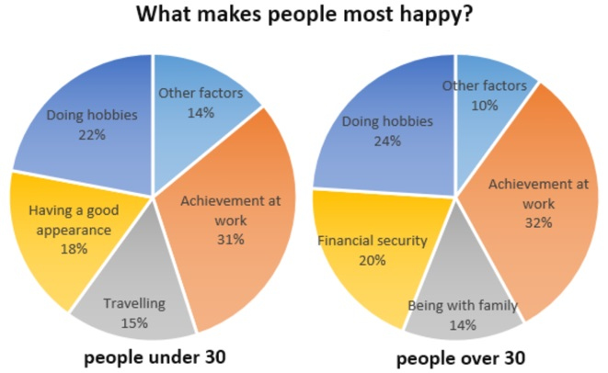

There are several similarities between what younger and older people say makes them most happy. However, there are several striking differences.

Firstly, let us look at the similarities. It is noticeable that for both younger and older people, the highest percentage says that achievement at work brings them most happiness:31% for the younger age group and 32% for the older group. Doing hobbies is also very important for both groups: the second largest percentage of both age groups mention doing hobbies as making them most happy.

Turning now to the differences, many younger people regard having a good appearance as extremely important: 18% of them state this brings them most happiness. This is followed by 15% who state that travel brings them happiness. Neither of these two factors is mentioned by older people. Instead, 20% of older people report that having financial security is most important to their happiness and 14% say they feel most happy when they are with their family.

## 79 Someland’s main exports

The chart below gives information about Someland's main exports in 2005, 2015, and future projections for 2025.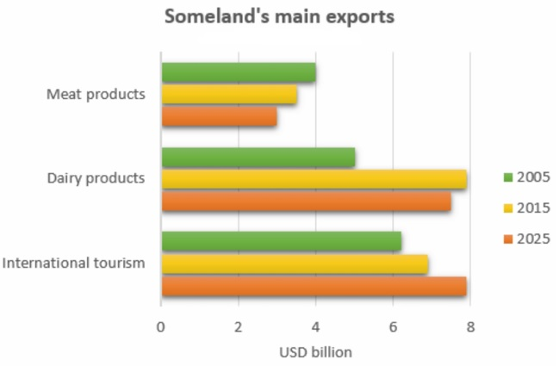

This bar chart illustrates the performance of Someland's primary exports in 2005 and 2015. It also indicates future projections for 2025. According to the data, it seems likely that international tourism will become the dominant industry, although dairy exports will remain strong. In 2005, we can see that tourism was the greatest exports earner of the three industries, with revenue standing at just over $6 billion.

This figure has increased slightly, so that now, in 2015, it has reached almost $7 billion. It is estimated that international tourism will continue to grow, so that by 2025, it will be earning around $8 billion for the country. In 2000, dairy exports were worth around $5 billion, but since then there has been a dramatic increase, and sales for this year are approximately $8 billion. Experts are predicting that exports in this area may fall slightly, so a figure of $7.5 billion is expected for 2025. Meat products are the third key industry in Someland, but sales have dropped since 2000 and now stand at $3.5 billion. It is expected that sales will continue to decrease in the future.

## 80 most common sports in New Zealand

The chart below gives information about the most common sports played in New Zealand in 2002.

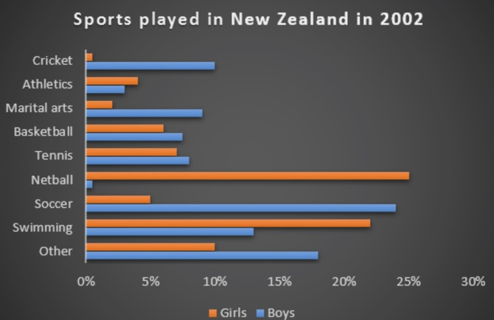

The bar graph provides information about the most Common sports played in New Zealand in 2002. It gives figures for both boys and girls and clearly shows that their participation in sports is fairly equal. However, their sporting preferences tend to be different.

According to the graph, the most popular sport among girls is netball, with participation rates reaching 25 per cent. A similar percentage of boys prefer soccer, which is clearly their favorite sport. Ten per cent of boys also enjoy playing cricket but hardly any girls take part in this game. While swimming is popular among both boys and girls, fewer boys participate in this sport - about 13 per cent compared to approximately 22 per cent of girls. Other sports such as tennis, basketball and martial arts have lower levels of popularity, and a significant percentage of boys and girls say they enjoy sports not referred to on the chart.

## 81 relative price changes for fresh fruits and vegetables

The graph below shows relative price changes for fresh fruits and vegetables, sugars and sweets, and carbonated drinks between 1978 and 2009.

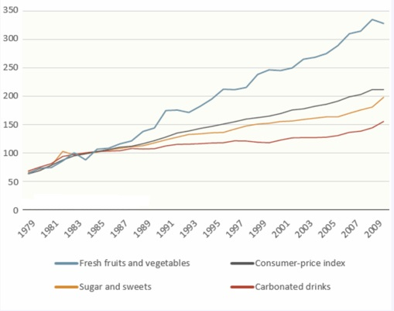

The graph shows changes in the price of fresh fruits and vegetables, sugar and sweets, and carbonated drinks over a thirty-year period in the US between 1979 and 2009. The graph also shows the general trend in the consumer price index during this time.

While the consumer price index showed a slow and steady increase from 1979 to 2009, the same cannot be said for the price of carbonated, or soft drinks. After rising briefly between 1979 and 1981, they remained fairly constant until 1999, when the price did begin to increase slowly.

In contrast, there was a marked difference in the price of fresh fruits and vegetables, which, despite periodic fluctuations, rose steadily throughout this period. In fact, fresh food prices only levelled out temporarily between 1990 and 1992 and again from 2000 to 2001. However, by 2008 the price had increased by more than 300%.

The graph depicts the comparative price fluctuations of fresh fruits and vegetables, sugars and sweets, and carbonated drinks from 1978 to 2009. It also includes the consumer-price index (CPI) as a measure of inflation.

To analyze this data, we examine the trends depicted in the graph:

1. Fresh Fruits and Vegetables: The line for fresh fruits and vegetables starts at roughly 50 in 1978 and exhibits a consistent upward trend over the years. By 2009, it appears to have reached approximately 300, indicating that the price of fresh produce has more than tripled relative to the CPI during this period.

2. Sugars and Sweets: This line begins at about 100 in 1978 and follows an upward trajectory, though not as steep as fresh fruits and vegetables. By 2009, it seems to be just above 200, suggesting that the price of sugars and sweets has more than doubled relative to the CPI.

3. Carbonated Drinks: The line for carbonated drinks starts near 50 in 1978 and increases at a slower rate compared to the other items. By 2009, it appears to be slightly above 100, indicating that the price of carbonated drinks has roughly doubled relative to the CPI.

4. Consumer-Price Index (CPI): The line for the CPI starts at approximately 100 in 1978 and ends near 300 in 2009, showing a threefold increase over the 31-year period.

From these observations, we can infer that the prices of fresh fruits and vegetables, sugars and sweets, and carbonated drinks have all increased relative to the general inflation represented by the CPI. However, fresh fruits and vegetables have seen the most significant relative price increase, followed by sugars and sweets, with carbonated drinks experiencing the smallest relative increase. This suggests a shift in the cost of living where basic food items like fresh produce have become relatively more expensive compared to other consumables. This trend could have implications on dietary choices and overall public health, as higher prices for healthy foods may discourage their consumption.

## 82 science qualifications

The chart below gives information about science qualifications held by people in two countries. 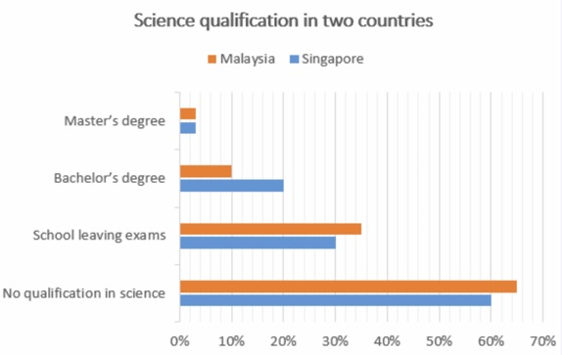

The bar chart illustrates the percentage of people who hold a science qualification in Singapore and Malaysia. A prominent feature is that a significantly low percentage of people hold science qualifications, that is Master's and Bachelor's degrees in science from university level studies in both countries. Less than 5% of people hold a qualification in science at Master's degree level in both Singapore and Malaysia.

There is a significant difference in the percentage of people holding science qualifications at Bachelor level between the two countries; while this number is 20% in Singapore, in Malaysia it is a mere 10%. The percentage of people with school leaving exams in science is slightly higher in Malaysia than in Singapore.35% of people in Malaysia have a science qualification at this level, whereas the number in Singapore is 5% lower. Finally, more than half the people in both countries hold no science qualification at all.

## 83 Employment by sex in 6 sectors

The graphs below show the numbers of male and female workers in 1975 and 1995 in several employment sectors of the republic of Freedonia.Write a report for a university teacher describing the information shown. 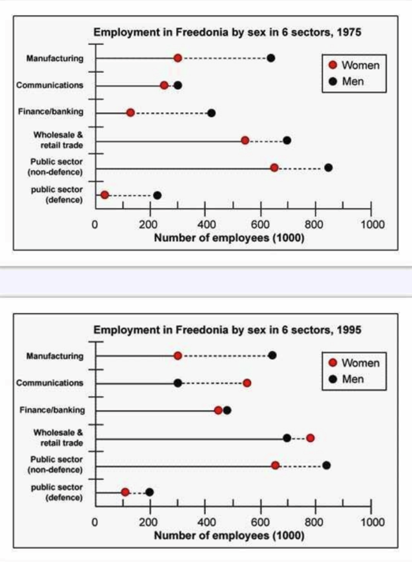

The diagrams compare the male and female employment status in six different job sectors in two different years -1975 & 1995. As is seen from the given illustration, men were well ahead of women in all the job sectors in Freedonia in 1975. However, the scenario changed in the 1995 and women did a remarkable progress in their professions.According to the given diagrams, men in Freedonia were well ahead of female in manufacturing, finance/banking, wholesale & retail trade, defence and non-defence sectors. In manufacturing more than 600 male employees could be seen against only 300 female employees out of a thousand employees. Except in communication sector, the proportion of male employees was far greater than that of females. Among the given job sectors, the public /non-defence sector had the highest number of employees while the defence sector had the least number of employeesAfter 20 years, women showed an outstanding advancement in the job sectors and they went well ahead of men in communication, wholesale & retail trade sectors. They become almost equal in number in finance and banking jobs while the gap between male and female employees' numbers reduced in defence jobs. The only sector that was still male dominant was manufacturing and the job ratio in this sector remained almost same as it was 20 years earlier

## 84 acid level in mouth consumption of sugar

Eating sweet foods produces acid in the mouth, which can cause tooth decay. (High acid levels are measured by low pH values)Describe the information below and discuss the implications for dental health.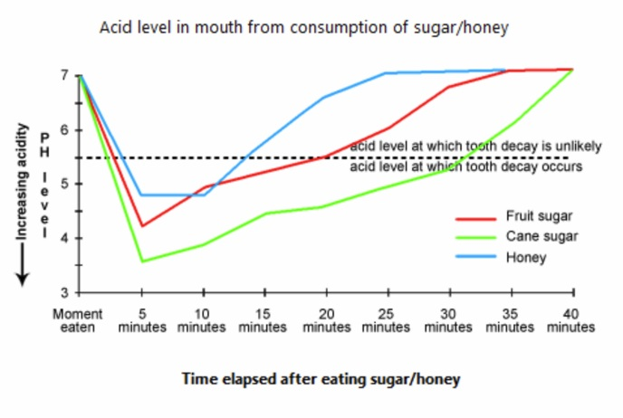

The provided line graph illustrates the acid level in the mouth which is created by consuming sweet foods specifically sugar and honey and the possibility of tooth decay because of this acid level. As is presented in the line-graph, the higher the acid level the lower the pH value and a pH level less than 5.5 is detrimental for the tooth and causes the tooth decay.

The given graph shows that the initial pH level of our mouth is 7 which begin to fall after consuming sweet foods. When we eat sweet item like cane sugar, the pH level drops to 3.5 after 5 minutes and remain in danger level (below pH level 5.5) for more than 30 minutes. Consuming fruit sugar drops the pH level nearly to 4 and remains in danger level for about 20 minutes. And finally, when we eat honey, the pH level falls below 5 and it remains under risk level for about 13 minutes. As the low pH level means higher acidity and causes tooth decay, cane sugar among the mentioned three food items is the most harmful for our tooth.

## 85 unpaid work for men and women in different categories

The diagram below shows the average hours of unpaid work per week done by people in different categories. (Unpaid work refers to such activities as childcare in the home, housework and gardening.)Describe the information presented below, comparing results for men and women in the categories shown. Suggest reasons for what you see.

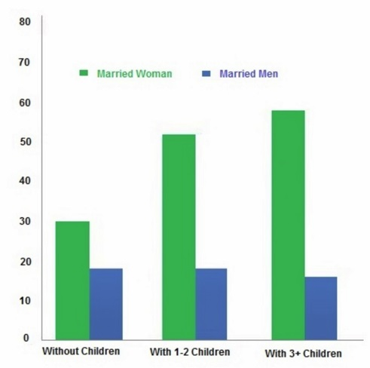

The graph shows data between married men and women of the number of hours spent per week on unpaid work. At first glance at the chart, it is noticeable that from all the three categories (without children, with 1-2 children and with 3 or more children), married women spend more hours involved in unpaid work such as housework, gardening and childcare than expected from men.

Married women with children spend more time than without children as the chart shows while having more than three children have invested around 60 hours of unpaid work. This is probably due to the extra load of housework and childcare that is evidently needed to run such a big family.

Furthermore, though there are visible variations of the number of hours of unpaid work carried out by married women, there is no significant variation among all three categories for married men in terms of work hours that is not paid (30 or fewer hours). In fact, it is observed that married men with three or more children spent slightly less number of unpaid work hours. This might be due to the high requirement of commitment needed for a paid job to meet financial requirements for a big family.

In conclusion, married women with three or more children spent the highest number of hours, yet married women from all categories spent a dramatically higher number of hours for unpaid work than married men.

## 86 mobile and landlines in selected countries

The chart shows the number of mobile phones and landlines per 100 people in selected countries.Write a report for a university lecturer describing the information given.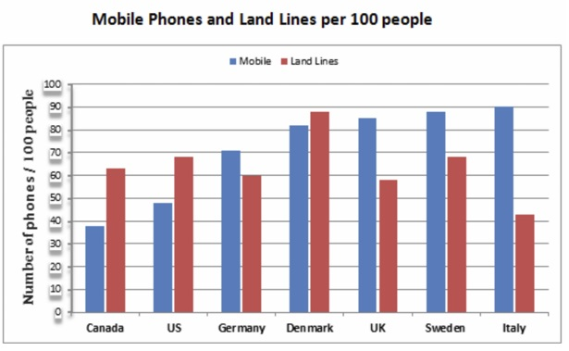

The supplied bar graph shows data on the number of cell phone and land phone users in seven countries in the Europe and the American regions. As is observed from the presentation, the number of landline users in Denmark, US and Canada are higher than the number of cell phone users in these countries.

On the contrary, in Italy, Sweden, Denmark and Germany the cell phone users are higher in number than that of land phone users. In Italy, Sweden, UK and Denmark almost 80-90 percent people use the cell phone. Among these six countries, Italian people are highest in percent in terms of cell phone usages whereas the highest percentages of land phone users are found in Denmark which is almost 90%. The difference between cell phone and land phone users is highest in Italy and in Denmark these two types of users are almost similar. The lowest number of land phone users can be found in Canada.

In summary, North America has more land phone users than their cell phone users and most of the European people prefer to use mobile phones over land phones.

## 87 underground station passenger numbers in London in a daily time

The graph shows Underground Station passenger numbers in London.Summarize the information by selecting and reporting the main features, and make comparisons where relevant.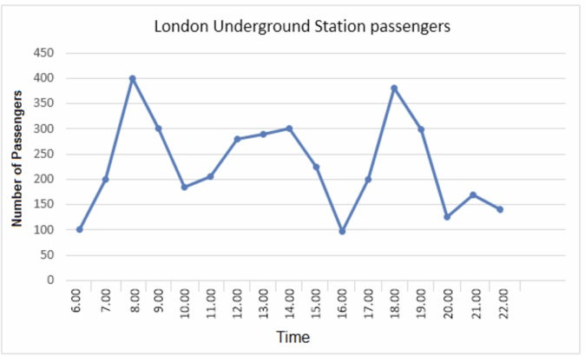

The given line graph shows data on the number of underground station passengers of London city from 6:00 am till 10:00 pm. As is observed from the graph, the highest number of people use the underground stations of London at 8:00 am and 6:00 pm.

At 6:00 am around 100 underground passengers can be found at the stations and this number increases seamlessly until 8:00 am when the passengers' number reaches to 400. After 8:00 am the number declines steadily until 10:00 am when it reaches around 180. The number keeps fluctuating until 4:00 pm and on an average 200 passengers can be observed during this period. After 4:00 pm the passenger number increases and reaches at 380 at around 6:00 pm. After 6:00 pm, the passenger number decreases with some fluctuations until 10:00 pm.

In summary, the highest number of passengers of London underground stations can be found in the stations during the office going and office leaving times in a day. Present a written argument to an educated reader with no specialist knowledge of the following topic:

## 88 factors affecting work performance

The bar chart below shows the results of a survey conducted by a personnel department at a major company. The survey was carried out on two groups of workers: those aged from 18-30 and those aged 45-60, and shows factors affecting their work performance.Write a report for a university lecturer describing the information shown below.

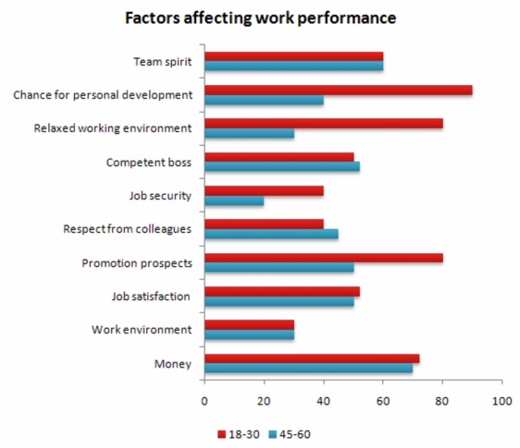

The supplied bar graph compares different factors which affect the work performance of two different age group.

As is presented as a result of a survey in the given bar chart, for the both age group of 18-30 and 45-60, team spirit affects work performance equivalently and that is little over 60%. The reason chance for personal development' works for the younger age group about 90% which is more than twice than the older age group. The similar scenario is true for the relaxing environment too and this reason affects more than 80% of the 18-30 age group workers and about only 30% of the 45-60 years workers.

About 45% younger workers' work performance is affected by the job security compared to little over 20% older workers. The only case where 45-60 years workers are influenced more than their younger counterpart is 'respect from colleagues' which is about 50% for this age group workers in contrast to 40% (approximately) for the 15-30 years age group. The promotional prospect is an important reason that drives younger employees to work better and this reason affects 80% younger workers compared to almost 45% aged job holders. For the lower age group job satisfaction, work environment & money affects their job performance about 50%, 30% & about 75% consecutively compared to about 45%,30% and 70% of 45-60 years job holders.

In short, workers job performance are highly affected by chance for personal development, team spirit, promotion prospects, job satisfaction and salary.

## 89 estimated world illiteracy rates by region and by gender

The chart below shows estimated world illiteracy rates by region and by gender for the year 2000.

Write a report for a university lecturer describing the information below.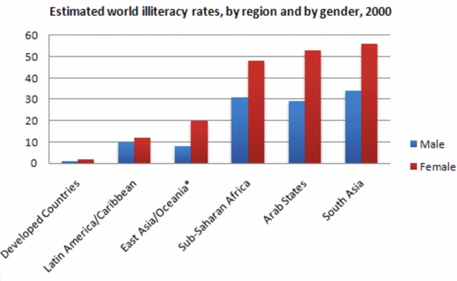

The column graph compares the illiteracy rates between both sexes in six regions of the world in 2000. A quick glance at the diagram reveals that more women were unlettered globally than that of men and the percentages of uneducated people in South Asia, Arab states and Sub-Saharan Africa parts were considerably higher than other parts of the world.

As is observed from the illustration, more percentages of women in different regions in the world were illiterate than that of men. Almost all of the citizens in the developed countries were literate in 2000 as the illiteracy rate in these countries was almost nill, 1-2 % to be more precise. The highest rate of illiteracy could be found in South Asia where more than half of women were not educated at all while more than one in every three males was also unschooled. A similar percentages of uneducated males and females could be found in the Arab and Sub-Saharan African regions and in all these regions the percentages of illiterate females were significantly higher than the uneducated males.

On the contrary, the percentage of East Asian population who were literate was far higher than that of the South Asian population and yet the per centage of female illiteracy was more than double than that of males. Finally, the Latin America had around 10% unenlightened males and females and the gap between the unlettered males and females in this region was remarkably lower, similar to the developed countries.